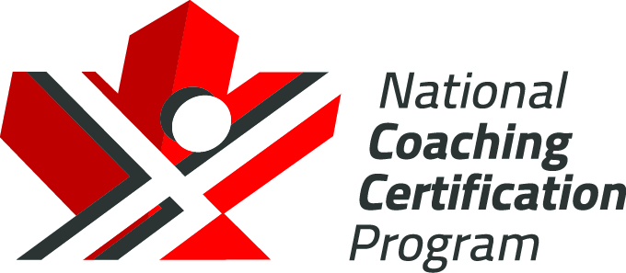

Hockey Canada
NCCP Instructional Stream
Checking Skills 1:
Reference Materials
Version 1.0, 2020

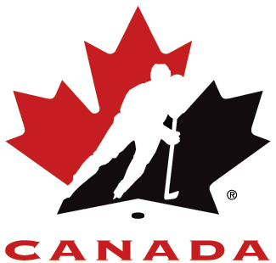

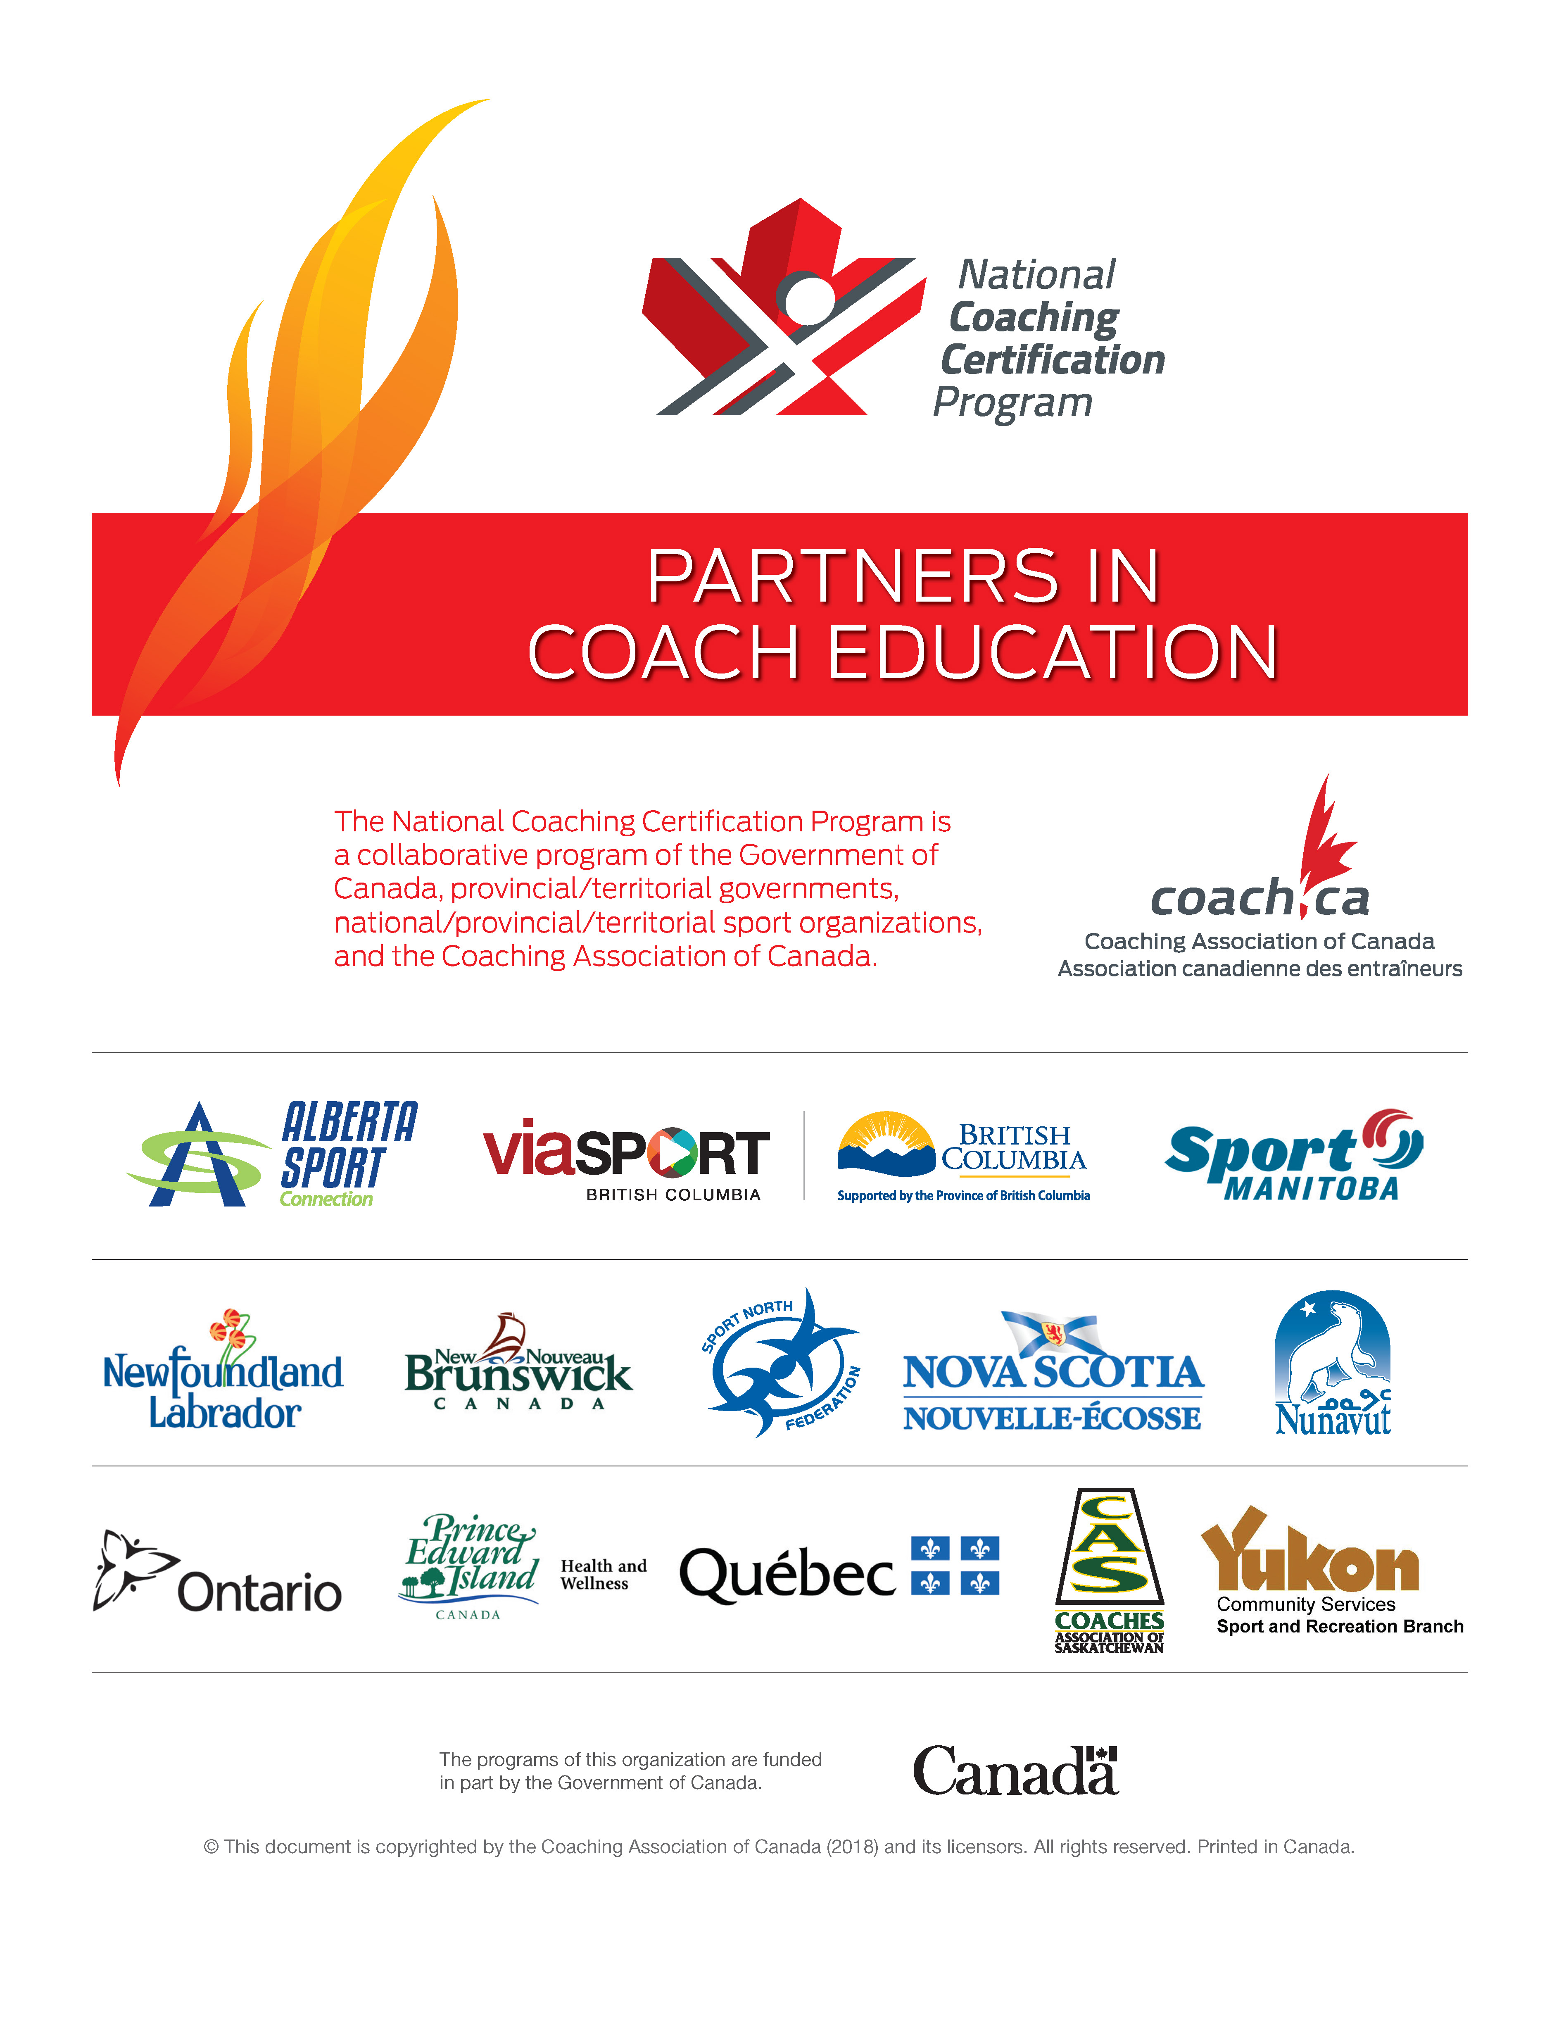

The Collection, Use, and Disclosure of Personal Information
The Coaching Association of Canada collects your NCCP qualifications and personal information and shares it with all NCCP partners according to the privacy policy detailed at www.coach.ca. By participating in the NCCP you are providing consent for your information to be gathered and shared as detailed in the privacy policy. If you have any questions or would like to abstain from participating in the NCCP please contact coach@coach.ca.

Copyright and government of Canada acknowledgement
2020 © Hockey Canada and Coaching Association of Canada. This document is copyrighted by the Coaching Association of Canada (2020) and its licensors. All rights reserved. Printed in Canada. No part of this publication may be reproduced, stored in a retrieval system or transmitted, in any form or by any means, without the express written permission of Hockey Canada and the Coaching Association of Canada. The National Coaching Certification Program (NCCP) is funded in part by the Government of Canada.

Part 1: Teaching Checking Skills

At the conclusion of this clinic you should be able to:
- Know the difference between Body Contact and Body Checking.
- Understand the age appropriate skills needed to develop better checking skills with your players.
- Identify the inherit risks associated with checking.
- Coach players and teach & develop their safe checking skills.
- Teach and design specific drills to develop vision and awareness.
- Understand and implement the proper checking progression needed for safe hockey.

Checking is a critical skill in hockey and when performed properly can create opportunities to help a team regain control of the puck. Just like skating, puck control, passing and shooting there are key progressions to the skill of checking. When these progressions are taught effectively, they can greatly enhance a player’s enjoyment of the game of hockey. Checking is a 4-step progression that starts with the first time a player steps on the ice. Body checking is the final step of the 4-step progression.

Body Checking Rule

In Under 13 divisions and below and Female hockey, a Minor penalty or, at the discretion of the Referee, a Major Penalty and a Game Misconduct penalty shall be assessed to any player who, in the opinion of the Referee, intentionally body checks, bumps, shoves or pushes any opposing player. If a player is injured, a Major penalty and a Game Misconduct penalty must be assessed.

During the 2013 Hockey Canada meetings in Charlottetown, PEI, the Hockey Canada Board of Directors approved the motion to change the body checking rule in the Hockey Canada Playing rules. Rule 6.7 (b) now states that a penalty shall be assessed in Under 13 divisions and below and Female Hockey to any player who intentionally body checks a player on the opposing team.

Recommended Definition: Body Contact

Body Contact: Incidental contact of two opposing players in pursuit of the puck or position on the ice in the same direction. Body Contact occurs as a result of movement by the offensive player. (Canadian Hockey Association, 2002)

Body Contact – No penalty
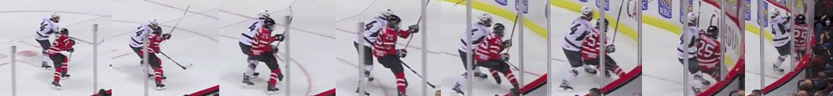

Recommended Definition: Body Checking

Body Checking: An attempt by a player to gain an advantage on the opponent with the use of the body. Body checking results when two opposing players collide while skating in opposite directions or when positioning and angling allow the checker to use the force of the body to gain the advantage. (Canadian Hockey Association, 2002)

During the 2013 Hockey Canada meetings in Charlottetown, PEI, the Hockey Canada Board of Directors approved the recommendation that all Branches adopt the definitions for Body Contact and Body Checking as originally submitted by the CAHA Coaching Committee in 1991. These definitions appear in the resource – Teaching Checking: A Progressive Approach (Canadian Hockey Association, 2002).

The “qualifier” that most officials look for in determining whether or not a Body Checking penalty should be called is: “Is the checker skating in the opposite direction to the puck carrier when contact is made?”

Body Checking – Penalty
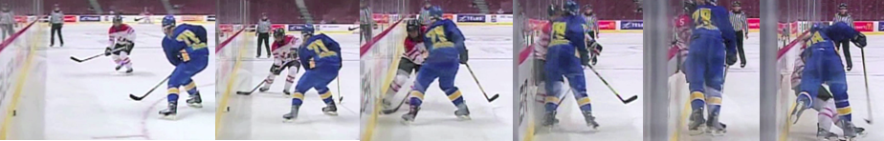

Part 2: Developing a Skill Base

Skill Acquisition in Young Players

Developing a Skill Base

Rationale: The skill of checking is most easily taught and understood by following the National Coaching Certification Program (NCCP) 4-step progression model. The NCCP checking model is based on the principle that checking should be taught in four logical steps. Each step builds upon the previous step and brings the hockey player that much closer to being able to give and receive body checks competently and confidently.

NCCP Checking Skills Model
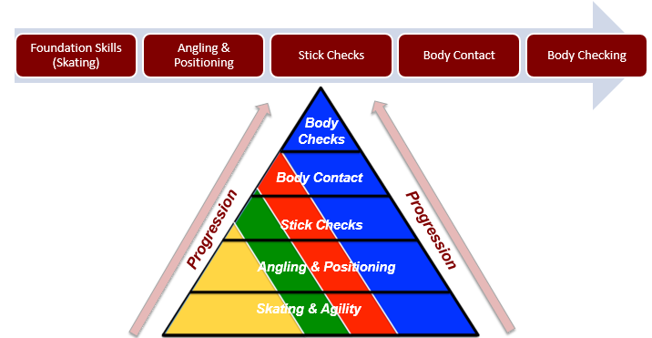

Tasks

What is the primary purpose of checking?
- To regain possession of the puck.
- Separate the puck from the puck carrier in a legal and safe manner.
- Delay or contain your opponent to enable your back checkers to assist.
- The game has changed: puck first!
What are the characteristics of a good checker?
- Skating Ability
  - Speed: Not only speed in skating up and down the ice but also laterally, quick change of directions. Also refers to reaction speed of poke check and skating checks.
  - Strength: Refers to the strength of the upper body, to overpower opponent’s stick, manipulation of opponent in close quarters.
  - Balance and Agility: Refers to the player’s ability to remain constantly in a ready position with a low center of gravity enhancing balance. Also refers to their skating ability to stop and change directions quickly, performing tight turns, use of crossovers, forwards and pivots or Mohawk turns while skating backwards, all performed while under control.
- Anticipation: Refers to the ability of a player to “read” the opposition’s weaknesses and strategies and counter them with checking techniques.
- Positional Ability: Refers to a player’s knowledge of angles while checking an opponent on the ice. It also refers to a player’s timing and the ability to “invite” or force an opponent to go in the direction he wants him to go. In addition, the player must always be prepared to work checking skills from a defensive side position, that being, always between the puck and his/her team’s net.
- Read and React Skills: Refers to the ability of a player to “read” and view the ice surface and player movements as the play progresses and be aware of options that are available to him should situations occur that precipitate a certain move or reaction.
  - A defenseman watches a play and the players as they move towards him. He is watching both the opposition and his teammates.
  - A forward forechecking or back checking watches the opposition and is aware of potential pass receivers but also aware of teammates and their proximity to opponents for checking purposes while forechecking.
  - A good checker not only knows the movements and position of his players but also the “habits” and patterns (i.e. favorite plays) of the opposition. He must also possess good body strength, especially that of the upper body, in order to outmuscle the opponent in the various checking techniques.
  - Overall body position is the final quality of a good checker. This refers to the “ready position” of a player to enable him to: proceed in any direction to pursue his opponent, resist an opponent’s “counter to check”, a good “ready” position requires a low center of gravity.

- Tenacity: Refers to the hockey player’s desire to move quickly and aggressively to a checking situation or to the puck. The more a player moves to put pressure on a puck carrier, the chances of success are greater.
- Desire: The player understands the need and the purpose to check the opponent. He/She is willing to participate in this part of the game, knowing and understanding the importance and the dangers of checking.

Safe Checking

- Improve skating
- Keep head up
- Stay aware and alert
- Always approach the boards on an angle
- Absorb with your arms
- Avoid the danger zone
- Never hit from behind
- Never hit to the head
- Control your stick
- Never make suicide passes
- Communicate
- Respect everyone

Important Nevers
- Never cross-check an opponent into the boards or anywhere on the ice.
- Never push, shove, or trip an opponent into the boards.
- Never use the butt end of your stick to hold or hook an opponent.
- Never check an opponent from behind or target a player’s head.

Important Rules to Remember
- Always be aware of the “Danger Zone” along the boards.

- Absorb impact along the boards with your arms and body.
- Always maintain a strong balanced position when giving or receiving a check. For better balance, maintain a wide stance, bending at the knees for good leg extension.
- Always keep sticks low and on the ice.
- When completing the check, insure the safety of the player being checked.
- Keep an eye on the opponent at all times.
- Never attempt to body check from an off-balance position.
- Always show respect for the opponent.
- Always ensure that a full and proper warm-up is done prior to conducting contact and body checking drills.

Part 3: Teaching Skills

The Four Phases of Checking
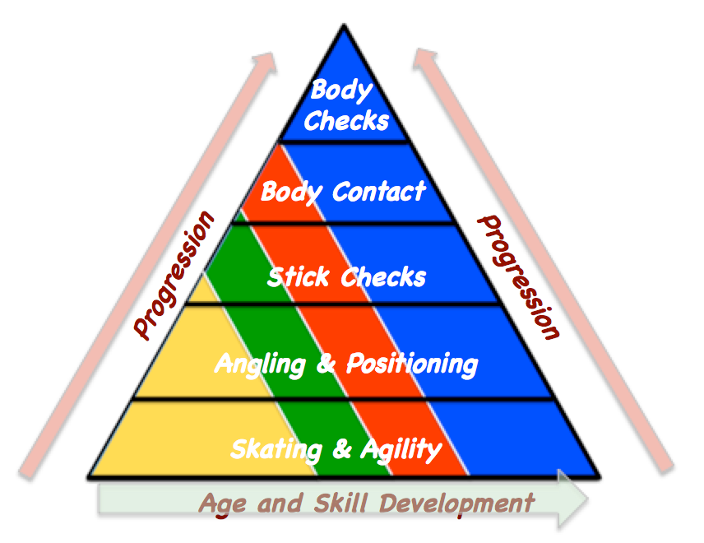

- Skating and Agility Skills
U7 & 9 U13 U15/U18

- Forward and Backward Striding
- Forward and Backward pivots
- Transition Skating
- Edge Control
- Agility, Balance and Coordination

Skating and Agility Drills (from the Clinic Ice Plan)
Drill Name & Description
Skating – Warm Up 1 - Forwards
- Players line up in two lines on the hash marks.
- Both lines can go at the same time, or each line can alternate, skating down the middle to the far end and then back along the boards.
- Perform each skating skill as shown.

Key Teaching Points
- Technique is important in this warm-up to give the players lots of repetition on technical aspects of skating.

Drill Name & Description
Balance and Agility - Evasive Skating
- Players line up facing each other inside blue line.
- Defensive player starts skating backwards trying to elude forward who acts as forechecker. Quick, deceptive moves to try and lose the forechecker. Start with no puck.
- Forechecker tries to contain, angle and react, and use stick position to steer defenseman.
- Add puck, defender must skate out of zone. If offensive player gets puck, then try to score.

Key Teaching Points
- Quick Feet, deception, agility.
- Both players need to read and react.
- Turn into 1 on 1 for intensity and competition.

Drill Name & Description
Balance and Agility – Rabbit - Coyote
- Players pass back and forth and can move anywhere. On the whistle, it becomes a game of keep away. When the coach blows the next whistle, whoever has the puck gets a point. Immediately start passing again and wait for the next whistle. Make it a best of 5 or 7.

Key Teaching Points
- Offensive player protects the puck. Keep body between the puck and the checker. Use your body to shield the opponent.
- Defensive player needs to close the gap, get stick on puck and body on body. Defensive player needs to “take his stick with him” and keep it on the ice.
- Coaches make sure players play penalty free.

Drill Name & Description
Balance and Agility – Stick Battles #1
- Players face each other and each one grabs the end of their partners’ stick so they have both have a stick in each hand and each holding on to the same stick.
- On the whistle players wrestle to throw their opponent off balance.
- A player is considered off balance when a body part other than the skates touch the ice.
- Push and pull – go for 15–20 seconds, then rest for 15 or 20 and repeat.

Key Teaching Points
- Solid and strong - wide stance.
- Get low.
- Use strong legs as the base.

Drill Name & Description
Balance and Agility – Stick Battles #2
- Use one stick placed horizontally between two players and they both place both hands on the stick shaft
- On the whistle each player tries to push or pull their opponent off balance.
- Push and pull – go for 15–20 seconds, then rest for 15 or 20 and repeat.

Key Teaching Points
- Wide and low.
- Drive with legs.

Drill Name & Description
Balance and Agility – Own the Dot #1
- Players position themselves at a faceoff dot and place a puck on the dot.
- Players are positioned back to face.
- On whistle player furthest from puck is trying to knock the puck off the dot, the player closest to the dot is trying to keep the puck on the dot.
- Must keep hands and stick down and play it “clean.”

Key Teaching Points
- Elbows down, stick on the ice.
- Good low stable body position.
- Drive with the legs.

Drill Name & Description
Balance and Agility – Own the Dot #2
- Players position themselves at a faceoff dot and place a puck on the dot.
- Players are positioned face to face.
- On whistle, player furthest from puck is trying to knock the puck off the dot; the player closest to the dot is trying to keep the puck on the dot.
- Must keep hands and stick down and play it “clean.”

Key Teaching Points
- Elbows down, stick on the ice.
- Good low stable body position.
- Drive with the legs.

- Angling and Positioning Skills

U7 & U9 U11 U13 U15/U18

- Read and React/Stall and Contain
- Shoulder Alignment – Inside/Outside
- Protect the middle of the ice
- Timing, Location, Gap Control
- Stance, Posture, Balance & Agility
- Receiving a Check/Contact Confidence

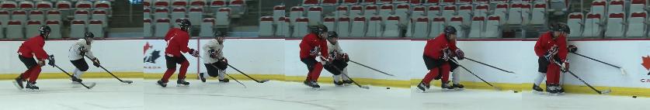

Angling Skills
- Open Ice Angling
- 1 vs. 1 Angling
- Corner Angling
- Open Ice Contain
- Safe Puck Retrievals

Angling and Positioning set the foundation for the next 3 phases of checking. They may be affective without resulting in body contact.

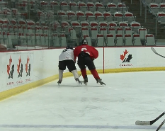

Key Teaching Points
- Stick on puck and body on body.
- Defensive player needs to keep a tight gap on the offensive player, keep shoulders square and limit crossovers, try to stay within one stick length.
- Most important aspects are timing and angling. If those are right, the defensive player can simply take the puck away.

Angling and Positioning Drills (from the Clinic Ice Plan)
Drill Name & Description
Angling – Open Ice Contain
- Players line up facing each other inside blue line.
- Defensive player starts skating backwards trying to elude forward who acts as forechecker. Quick, deceptive moves to try and lose the forechecker. Start with no puck.

Key Teaching Points
- Quick Feet, deception, agility.
- Both players need to read and react.
- Turn into 1 on 1 for intensity and competition.

Drill Name & Description
Angling – Circle Angling
- Key concept is for the defensive player to get and keep a tight gap on the offensive player.
- Offensive player skates the circles and defensive player tries to stay a stick length away.
- The drill then turns into a 1-1 drill back at the net.

Key Teaching Points
- Defending player keeps a tight gap on the offensive player.
- Defensive player keeps shoulders square and tries to limit crossovers.
- Defensive player tries to stay within one stick length
- Use proper form on transitions both backward to forward and forward to backward.
- On the 1-1, defensive player takes inside ice and keeps the attack outside.
- Stick on puck, body on body.

Drill Name & Description
Angling – Puck Retrievals
- Start with pucks in the faceoff circle, 2 players start in circle.
- Coach dumps puck in corner and designates one player (player on inside of ice) to be the retriever and the other (player closest to boards) to put on passive forecheck pressure.
- Coach dumps puck so it bounces off the boards in the corner.
- Puck retriever has to take proper lane to puck - stick fake, head fake, and/or shoulder check going into the corner to retrieve puck
- Drill is designed to give players confidence in retrieving pucks and to learn the proper path to getting loose pucks when an opponent is nearby.

Key Teaching Points
- Get to puck first – first in first out.
- Utilize fake to throw off forechecker.
- Can go either way, up boards or behind net.

Drill Name & Description
Angling – Corner Angling
- Pucks and players in faceoff circle.
- Coach dumps puck into corner, player on inside skates towards corner and retrieves puck.
- Player on outside, must take proper path and angle to force the puck carrier up the boards so the puck can be turned over.
- Must match speed of offensive player, stick on stick (stick on puck) and be in a position so the puck carrier cannot turn back the other way.

Key Teaching Points
- Control skate, take proper pathway.
- Stick on Puck, force puck carrier into poor position so puck can be taken away.

Drill Name & Description
Angling – 1 on 1 Angling
- Players line up in two lines outside the blue line. Player on boards has puck and is on offence, player in middle of ice is on defence.
- On whistle, offensive player starts skating forward, defensive player starts skating. backwards. Defensive player angles offensive player into boards so he can take the puck.
- Defensive player has to take away time and space and must properly time pivot to turn to the outside to face the offensive player.

Key Teaching Points
- Use drill to teach both offence and defence tactics.
- Defending player must control skate and gradually take away time and space.
- Most important aspect is the angle and the timing – if those are right, the defensive player can simply take the puck.

Drill Name & Description
Angling – Open Ice Angling
- Place 2 pylons in the zone as shown, players in two lines at the blue line.
- Offensive player skates towards own end with puck, defensive player skates a path inside. Offensive player skates around bottom pylon and turns towards boards to then skate up ice and out of the zone. Defensive player skates towards top pylon, pivots to the boards and then skates backwards to angle the offensive player towards the boards to try and keep the puck in.

Key Teaching Points
- Use drill to teach both offence and defence tactics.
- Proper timing and body position by defensive player.
- Keep inside shoulder lined up with outside shoulder of offensive player, stick on puck.

- Stick Check Skills

U7 & U9 U11 U13 U15/U18

- Skating Skills, Posture & Balance
- Stick on the ice – stick on puck
- Poke Check
- Sweep Check
- Stick Lift

Stick Checks
- Young players need the opportunity to practice and perfect stick checking skills
- The progression for developing stick checking skills:
  - Stationary practice
  - With movement
  - Small Area
  - Competitive games

Stick Check Drills (from the Clinic Ice Plan)
Drill Name & Description
Stick Checks – Stick on Puck
- Pucks and players in faceoff circle.
- Coach dumps puck into corner, player on inside skates towards corner and retrieves puck.
- Player on outside, must take proper path and angle to force the puck carrier up the boards so the puck can be turned over.
- Must match speed of offensive player, stick on stick (stick on puck) and be in a position so the puck carrier cannot turn back the other way.

Key Teaching Points
- Control Skate, take proper pathway.
- Stick on Puck, force puck carrier into poor position so puck can be taken away.

Drill Name & Description
Stick Checks – Stationary Poke Check
- Players in circle facing each other – offensive player stickhandles puck, defensive player is in front and ready to poke check puck.
- Player remains in a strong ready position stance.
- Tuck elbow with top hand only on the stick.
- Perform a quick extension of the arm and the stick straight out when the puck carrier is in the range of the check.
- Maintain the ready balanced position at all times.

Key Teaching Points
- Stay balanced and off toes of skates.
- Time poke check when puck is moving from the side to the front.

Drill Name & Description
Stick Checks – Stationary Sweep Check
- Players in circle facing each other – offensive player stickhandles puck, defensive player is in front and ready to sweep check puck.
- Top hand on the stick, the shaft of the blade lays flat on the ice.
- Sweeping motion of the stick to the side to knock the puck off the offensive players’ stick.

Key Teaching Points
- Stay balanced and off toes of skates.
- Time sweep check when puck is moving from side to side.

Drill Name & Description
Stick Checks – Stationary Stick Lift
- Players in circle standing next to each other – offensive player has puck, defensive player is to the side.
- Lift the opponent's stick on the shaft near the heel of the stick enough to retrieve the puck.
- After lifting the stick move body in front of the opponent to protect the puck and maintain control.

Key Teaching Points
- List stick near bottom of shaft.
- Take away hands of opponent after the stick lift.
- Move in front of body to protect puck.

Drill Name & Description
Stick Checks – Moving Poke Check
- Players start on boards in neutral zone.
- Offensive player skates into middle of ice, turns and bounces puck off boards and then picks it up to attack Defender 1 on 1.
- Defender mirrors offensive players’ path and transitions to play 1 on 1.
- When offensive player gets puck into range, defender extends stick and poke checks the puck off the stick.

Key Teaching Points
- Mirror offensive player, stay square.
- Keep a tight gap.
- Stay on balls of feet, don’t lunge.

Drill Name & Description
Stick Checks – Moving Sweep Check
- Players start on boards in neutral zone.
- Offensive player skates into middle of ice, turns and bounces puck off boards and then picks it up to attack Defender 1 on 1.
- Defender mirrors offensive players’ path and transitions to play 1 on 1.
- When offensive player gets puck into range, defender sweeps stick to the side to knock the puck off the stick.

Key Teaching Points
- Mirror offensive player, stay square.
- Keep a tight gap.
- Sweep stick to side to knock puck off stick.

Drill Name & Description
Stick Checks – Moving Stick Lift
- Pucks and players in faceoff circle.
- Coach dumps puck into corner, player on inside skates towards corner and retrieves puck.
- Player on outside, must take proper path and angle to force the puck carrier up the boards.
- Must match speed of offensive player, perform stick lift to take puck away.

Key Teaching Points
- Control Skate, take proper pathway.
- Stick on Puck, force puck carrier into poor position so a stick lift can be done.

- Body Contact/Contact Confidence

An individual defensive tactic designed to legally block or impede the progress of an opposing player.
U11 U13 U15/U18

- Receiving a Check
- Know the “Danger Zone”
- Body Position
- Stick on Stick/Shoulder to Shoulder
- Pinning
- Shoulder alignment (inside to outside)
- Do not push, shove, or change direction into the opposition

Body Contact Drills (from the Clinic Ice Plan)

Drill Name & Description
Contact Confidence – Wall Bump – Stationary
- Players are stationary standing parallel to the boards.
- Players should be close to the boards so that the skate nearest the boards is almost touching the boards.
- Players should be in proper hockey stance, knees bent, shoulders over knees over toes with feet slightly wider than shoulder width apart.
- On coach’s signal players should make contact with the boards – knee/hip/shoulder all make contact at the same time.
- Knees stay bent; arms stay low, stick on ice as player makes contact with the boards.
- Repeat several times and perform on both sides.

Key Teaching Points
- Keep knees bent, push up and in towards the boards to make contact.
- Keep elbow down and close to side when contacting the boards so the shoulder is the main point of contact.

Drill Name & Description
Contact Confidence – Wall Bump – Moving
- Players start stationary near the boards, on coach’s signal; players skate 3 strides then bump the boards, take 3 more strides and do it again. Can be done anywhere around the rink, make sure to go both ways so players get a chance to bump the boards using both shoulders.
- Players should be close to the boards so that the skate nearest the boards is almost touching the boards.
- Players should be in proper hockey stance, knees bent, shoulders over knees over toes with feet slightly wider than shoulder width apart.
- After 3 strides have been made, players should make contact with the boards – knee/hip/shoulder all make contact at the same time.
- Knees stay bent; arms stay low, stick on ice as player makes contact with the boards.
- Perform on both sides.

Key Teaching Points

- Keep knees bent, push up and in towards the boards to make contact.
- Keep elbow down and close to side when contacting the boards so the shoulder is the main point of contact.

Drill Name & Description
Contact Confidence – Partner Wall Bump – Stationary
- Players are lined up with a partner standing side by side and parallel to the boards.
- Inside player should be close to the boards so that the skate nearest the boards is almost touching the boards. Outside player should be close enough so that the skates are almost touching.
- Players should be in proper hockey stance, knees bent, shoulders over knees over toes with feet slightly wider than shoulder width apart.
- On coach’s signal, outside player should initiate contact with the inside player – with the shoulder being the principal point of contact. Player on inside should also push “up and out” to meet the contact.
- Knees stay bent, arms stay low, stick on ice as player makes contact with partner.
- Repeat several times and perform on both sides.

Key Teaching Points
- Keep knees bent, outside player pushes up and in towards the player on the inside to make contact.
- Keep elbows down and close to the side when contact is made so the shoulder is the main point of contact.

Drill Name & Description
Contact Confidence – Partner Wall Bump – Moving
- Players are lined up with a partner standing side by side and parallel to the boards. Players skate 3 strides then bump take 3 more strides and do it again. Can be done anywhere around the rink, make sure to go both ways so players get a chance to bump using both shoulders.
- Inside player should be close to the boards so that the skate nearest the boards is almost touching the boards. Outside player should be close enough so that the skates are almost touching.
- Players should be in proper hockey stance, knees bent, shoulders over knees over toes with feet slightly wider than shoulder width apart.
- On coach’s signal, outside player should initiate contact with the inside player – with the shoulder being the principal point of contact. Player on inside should also push “up and out “ to meet the contact.
- Knees stay bent, arms stay low, stick on ice as player makes contact with partner.
- Perform going in both directions and have players change positions to practice both roles from both sides.

Key Teaching Points

- Keep knees bent, outside player pushes up and in towards the player on the inside to make contact.
- Keep elbows down and close to the side when contact is made so the shoulder is the main point of contact.

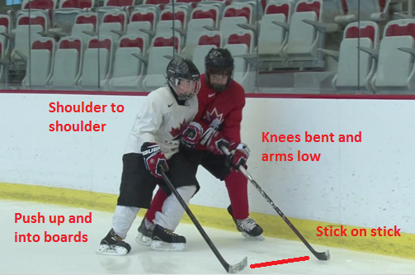
Drill Name & Description
Contact Confidence – Partner Wall Bump – Reverse
- Players are lined up with a partner – one facing forward, the other facing backward. Outside shoulder of forward-facing player should be in line with inside shoulder of backward-facing player. Players each skate 3 strides then bump take 3 more strides and do it again. Can be done anywhere around the rink, make sure to go both ways so players get a chance to practice both roles.
- Forward-facing player should be close to the boards to absorb the contact. Backward-facing player will move up and in to put the shoulder into the chest of the oncoming player.
- Players should be in proper hockey stance, knees bent, shoulders over knees over toes with feet slightly wider than shoulder width apart.
- On coach’s signal, outside player should initiate contact with the inside player – with the shoulder being the principal point of contact. Player on inside should be close to the boards to absorb the contact.
- Knees stay bent, arms stay low, stick on ice as player makes contact with partner.
- Perform going in both directions and have players change positions to practice both roles from both sides.

Key Teaching Points

- Keep knees bent, outside player pushes up and in towards the player on the inside to make contact.
- Keep elbows down and close to the side when contact is made so the shoulder is the main point of contact.

Drill Name & Description
Contact Confidence – Stationary Bump
- Place 3 players in a circle all facing the same way and in their hockey stance.
- Player in middle has to be ready to absorb the contact by staying in a balanced hockey stance and ready for the contact.
- Players on the outside alternate bumping the player in the middle.
- Player in middle can initiate contact with players on the outside.
- 3 – 5 bumps from each player then change positions.

Key Teaching Points
- Make sure players stay low, with elbow in, stick on ice and lead with shoulder not head.
- Rotate players through all 3 positions.

Drill Name & Description
Contact Confidence – Partner Bump Open Ice
- Players line up side by side in pairs along blue line.
- Pairs move across ice bumping each other with shoulders.
- Take 3 strides each and bump.
- Make sure to lead with shoulders and not the head.

Key Teaching Points
- Low, wide, strong position.
- Initiate the bump with drive from the legs.

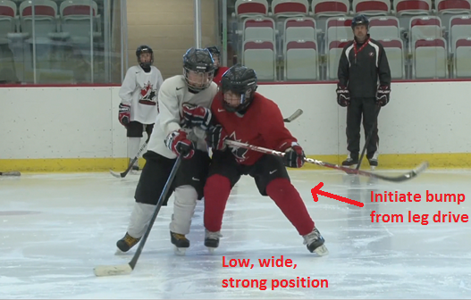

Drill Name & Description
Contact Confidence – Circle Bump
- Place 4–5 players around the outside of the circle with inside foot on the circle and shoulder facing the centre dot.
- One player on the dot in the middle of the circle.
- On coach’s signal, player in middle skates towards any of the players on the outside and tries to bump them off the circle using only the shoulder.
- Both players must stay low and use shoulders to absorb hit.
- After player in middle hits each of the players on the outside, change players.

Key Teaching Points
- Low, wide, strong position.
- Initiate the bump with drive from the legs.

- Body Checking and Respect

Effective body checking is built upon the first 3 phases of the checking progression:
- Strong, controlled and balanced skating
- Good stick position
- Good angling approach
U15/U18

PROGRESSION SKILLS

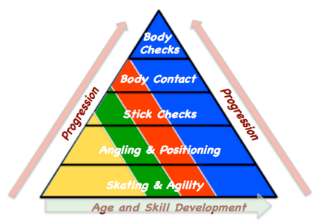
- Respecting the opponent
- Giving a body check
- Receiving a body check

- Defensive positioning
- Stick on puck/body on body
- Stick in lanes
- Communicate
- Head on swivel
- Straight line skating
- Angle and steer
- On ice awareness

Body Checking Drills (from the Clinic Ice Plan)

Drill Name & Description
Contact Confidence – Receiving a Body Check
- Place two pylons as shown on the ice.
- One player skates forward with the puck down below the low pylon, turns towards the boards and skates up ice with the puck towards the blue line, the other plays skates forward below the high pylon then pivots and skates backward.
- Player now skating backwards angles off the puck carrier and makes contact along the boards.
- Player skating forwards practices getting into position to receive the body check. Close to boards, knees bent arms and stick down using the boards to absorb the contact.

Key Teaching Points
- Keep knees bent, outside player pushes up and in towards the player on the inside to make contact.
- Keep elbows down and close to the side when contact is made so the shoulder is the main point of contact.

Drill Name & Description
Body Checking – Giving/Receiving 1
- Players line up along boards as shown.
- Player near boards has a puck and skates forwards into the zone. Player skating backwards has to angle off the puck carrier and deliver a body check to the puck carrier.
- Player skating forwards practices getting into position to receive the body check. Close to boards, knees bent arms and stick down using the boards to absorb the contact.
- Player delivering the body check must keep knees bent, arms down and stick on ice – after contact is made, defensive player should look to find the puck and be ready to go on offence.

Key Teaching Points
- Keep knees bent, outside player pushes up and in towards the player on the inside to make contact.
- Keep elbows down and close to the side when contact is made so the shoulder is the main point of contact.

Drill Name & Description
Body Checking – Giving/Receiving 2
- Place two pylons as shown on the ice.
- One player skates forward with the puck down below the low pylon, turns towards the boards and skates up ice with the puck towards the blue line, the other plays skates forward below the high pylon then pivots and skates backward.
- Player now skating backwards angles off the puck carrier and makes contact along the boards.
- Player skating forwards practices getting into position to receive the body check. Close to boards, knees bent arms and stick down using the boards to absorb the contact.

Key Teaching Points
- Keep knees bent, outside player pushes up and in towards the player on the inside to make contact.
- Keep elbows down and close to the side when contact is made so the shoulder is the main point of contact.

1 on 1 Situations

- “Play the man”, not the puck
- Head up, eyes on eyes or chest
- Stick out front for pressure, bent elbow “stick on puck” and “body on body”.
- Good balance, don’t lean or lunge
- Outside shoulder to inside shoulder
- Keep the play wide until help arrives

Use of Small Area Games

- Competitive situations where you can teach all the checking skills
- Controlled situations where you can teach progressions

Checking Tactics

- Gap control
- Protect middle of the ice
- Balance
- Stick Checks
- Body contact
- Awareness on the ice
- Talk and communicate
- Inside-out forecheck
- Back Pressure
- Skating
- Timing
- Contain or pressure
- Defensive side coverage
- Angle and steer
- Taking hits
- Stay square to the opponent
- Respect opponent

Players deserve a safe and enjoyable experience that includes:
- Respect
- Sportsmanship
- Safety within the game

