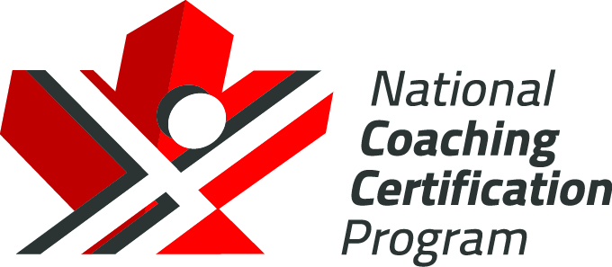

Hockey Canada
Coach 1 – Intro to Coach:
Reference Material
Version 1.1, 2020

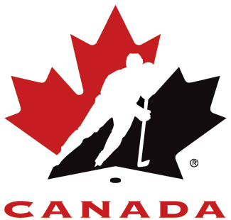

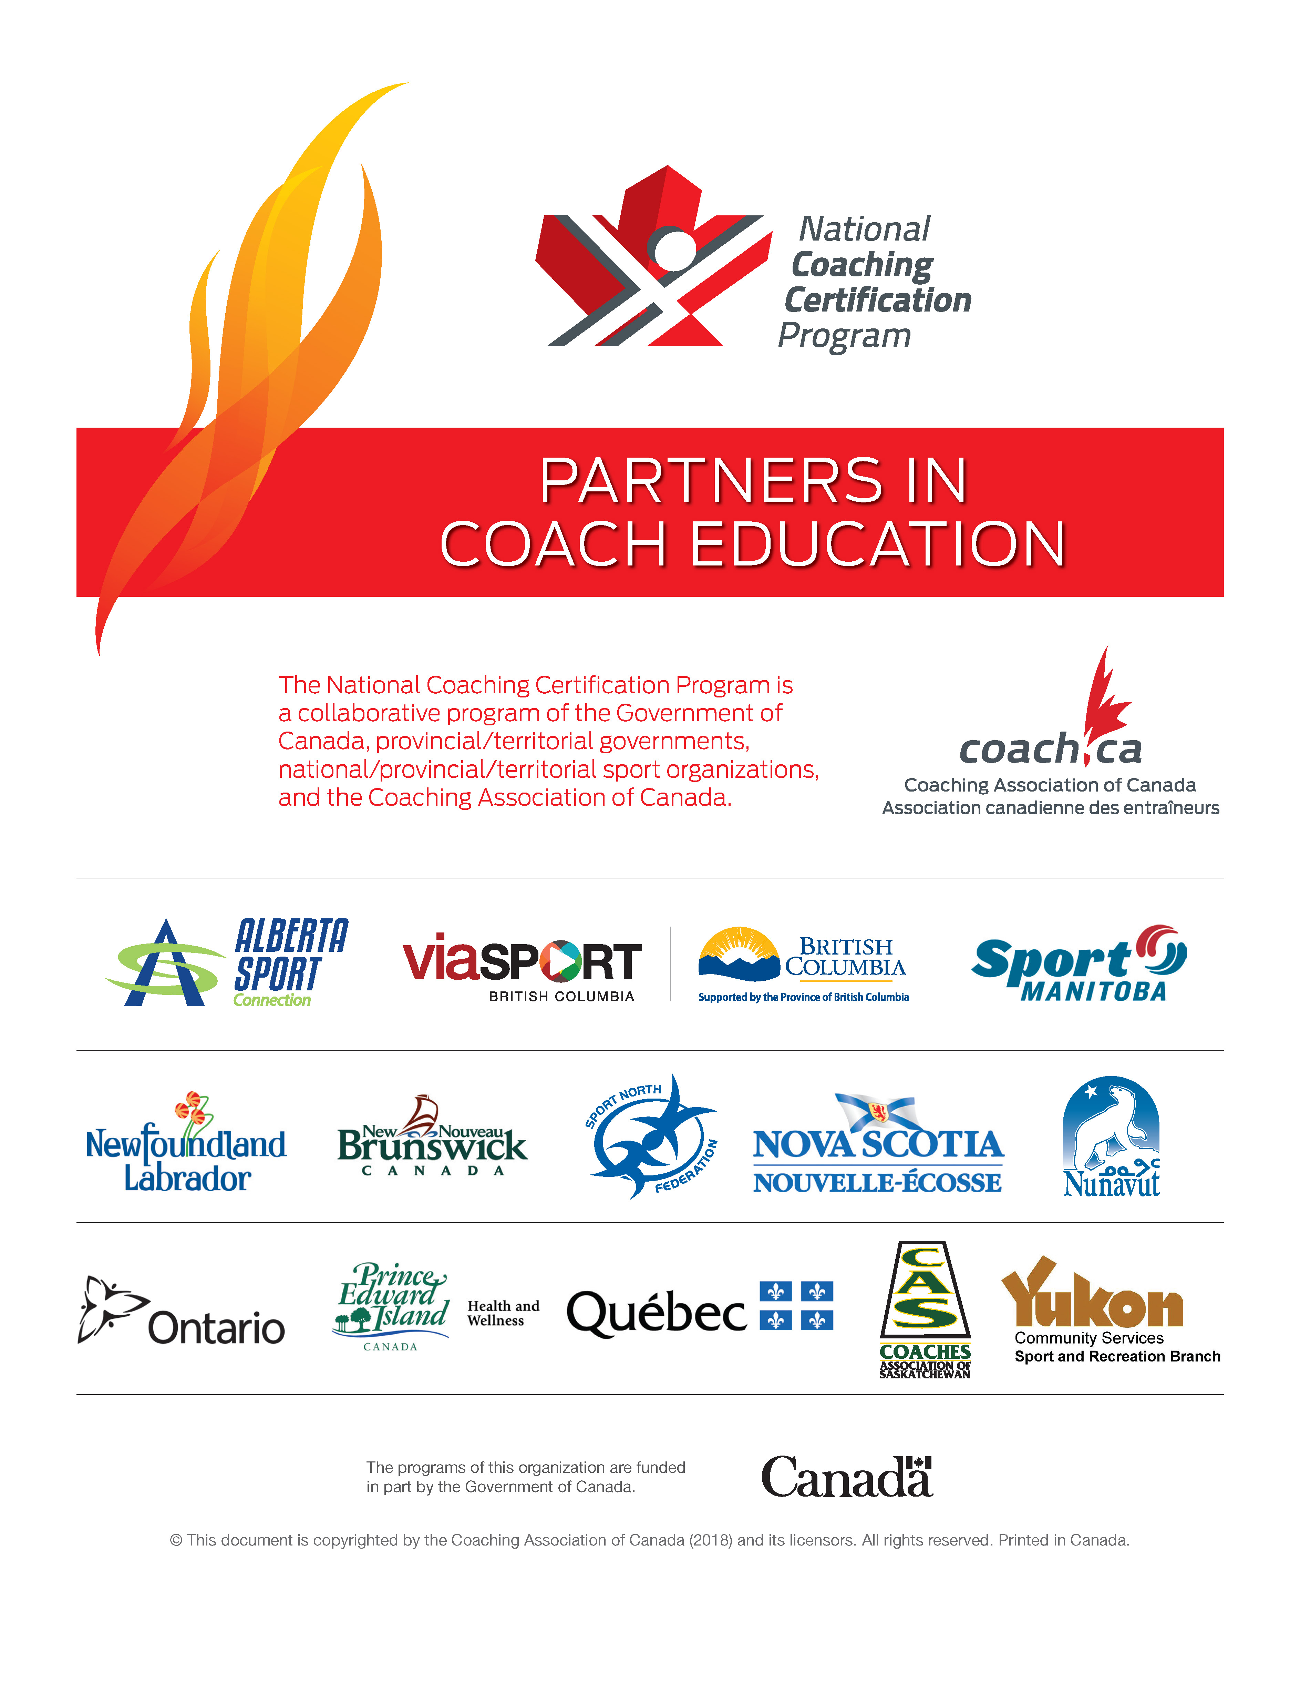

Table of Contents
Module 1 – Growth and Development 1
Factors Affecting Learning 1
Basic Principles of Growth and Development 2
Module 2 – Lesson Organization 6
Planning and Preparation 6
Teaching Stations 7
Team Teaching 8
Organization of Equipment and Space 9
Grouping of Players 10
Drills and Games 11
Summary 11
Module 3 – Leadership / Communication 12
Leadership 12
Communication 16
Summary 22
Module 4 – Teaching Progressions, Teaching Methods, and Skill Analysis 23
Teaching Progressions 23
Teaching Methods 28
Summary 28
Skill Analysis 29
Summary 32
Module 5 – Safety 33
Injury Prevention 33
Warm-up 34
On-ice Safety 34
Protective Equipment 34
Annex A: Key Instructional Points 37
Pyramidal Definitions of Terms 37
The Importance of Skating 38
Basic Stance 38
Skate Edges 40
Forward Start 41
Forward Skating 43
Forward Stop 45
Forward Turn 47
Backward Skating 51
Backward Turn 53
Puckhandling 55
Passing 58
Shooting 61
Deke 64

The Collection, Use, and Disclosure of Personal Information
The Coaching Association of Canada collects your NCCP qualifications and personal information and shares it with all NCCP partners according to the privacy policy detailed at www.coach.ca. By participating in the NCCP you are providing consent for your information to be gathered and shared as detailed in the privacy policy. If you have any questions or would like to abstain from participating in the NCCP please contact coach@coach.ca.

Copyright and government of Canada acknowledgement
2020 © Hockey Canada and Coaching Association of Canada. This document is copyrighted by the Coaching Association of Canada (2020) and its licensors. All rights reserved. Printed in Canada. No part of this publication may be reproduced, stored in a retrieval system or transmitted, in any form or by any means, without the express written permission of Hockey Canada and the Coaching Association of Canada. The National Coaching Certification Program (NCCP) is funded in part by the Government of Canada.

Module 1 – Growth and Development
The player in the U7 Program needs:
- to have fun and enjoy hockey and physical development
- to refine basic motor patterns
- to experience activities that are challenging and ongoing
- to receive reinforcement and experience success to build positive self-concept
- to try, experiment, play and pretend in unstructured activities and adapted game situations
to be introduced to the concepts of cooperation and sportsmanship

Factors Affecting Learning
The factors which affect the way in which an individual learns skills can be viewed from a variety of different perspectives. The main ones are:
- the learning environment
- instructor traits
other factors which influence learning

The Learning Environment:
- should be completely under the control of the instructor
- there should be reward for success given at every opportunity
- encouragement must be provided to assist in the improvement of skills
- focus on the players' ability not their personality
- focus on the correction of errors not criticism of the individual. Correct major errors at once.
- provide free time to experiment with new skills in self-teaching mode
- factors which often inhibit learning:
- excessive enthusiasm
- negative attitude
- poor equipment
- poor teaching aids

Instructor Traits
Some of these may seem familiar to you after having completed the section of Leadership. Many good leadership qualities also are good instructor traits. They are important enough to bear repeating;
- knowledge of the game, the components of the basic skills and how and when to introduce them.
- to be able to express the knowledge that you have at the players' level of competence and in a manner which will motivate and challenge them.
- relating to the players in a friendly, courteous and respectful manner.
- the ability to identify learning limits, the skill level and level of interest of the players.
- the ability to capture and hold the players' attention and to emphasize the "do" of learning.
- the knowledge of the level of tolerance of the players so that the learning demand is not more than they can handle.
be prepared, creative and enthusiastic.

Other Factors
- guide and monitor the learning process; be aware of progressions in learning — work from the simple to the difficult.
- new skills should be introduced on a solid basis, for example at the beginning of a lesson they should be built on previous lessons and should be emphasized until mastered.
ice sessions should be planned around the level of competence and interest of the players, their ability to understand instructions and their attention span and capability to learn new skills as well as master old ones. Repeat drills for short periods of time over a large number of ice sessions and where-ever possible, praise good performance.

Basic Principles of Growth and Development

Growth and Development Considerations Players Aged 3-5

General Remarks
- Cannot see the difference between what is real and what is not
- Lives in an imaginary world
- Constantly imitates
- Highly dependant on parents
Needs to have well established routine in daily activities

Psycho-social
- Highly individualistic, even egocentric
- May be afraid of strangers
Boys and girls may be involved in the same activities without any problem.

Learning
- Period of life where significant progress is seen in areas such as ability to learn, intelligence and language; is capable of using notions such as age, time, space and good-bad more efficiently
- Very low ability to concentrate (short attention span); cannot understand abstract concepts
- Low ability to reason or solve problems
Cannot take into account most of the information or stimuli from environment

Physical
- Growth rate is slightly reduced compared to the first 2 years of life. Body proportions become more balanced. Head is fragile.
- Resting heart rate and heart rate during exercise higher compared to adults
Hand-eye coordination is improved, as well as speed/rhythm of execution of fundamental movements

Preferences
- Likes activities that stimulate several different senses as well as imagination
- Likes simple games with easy to understand tasks and rules
Prefers individual activities yet accepts to share his/her environment of play with others

To Avoid
- Any activity that is structured and requires attention
- Activities that feature repeated impacts or where there is a risk of collision
- Repetitive activities (for boredom and to prevent overuse activities
- Exposure to very hot or cold environment
- Comparisons between children
Emphasizing the result or performance

Suggestions
- Activities that feature a variety of motor experiences, and where the emphasis is put on the knowledge of the body and location of the body parts in space
- Simple explanations and provision of manual assistance to the child during the execution of movement
- All activities should take the form of games
- The instructions and the teaching must be specific, simple and aimed at a clear objective
- Children need to be praised and complimented regularly for their efforts
Creation of small groups where activities take the form of games with focus on balance, coordination, movements in all directions. Where possible, involve parents to create an opportunity to consolidate a close relationship with the child through play.

Growth and Development Considerations Players Aged 6 – 7

General Remarks
- Fairly individualistic and self centered
- High dependence on parents
- Acknowledges the instructor as the leader
- Needs well established routine in daily activities
- Little athletic or competitive background
Interest in sport activities growing

Psycho-social
- Rather individualistic; often tries to expand social circle and the number of friends, especially with individuals of the same sex
- Sometimes shy
- Is conscious of own feelings and emotions, and those of others toward him/her. Can play on these feelings to obtain certain privileges or certain things
Boys and girls can be involved in same activities without difficulty

Learning
- Learns best by observing, quickly followed by doing
- Short attention span, ability to reason is limited to what is observable
- May be afraid of the unknown
- Is likely to imitate and be highly imaginative - often curious and wants to know everything
Is capable of dealing with some stimuli from the environment
You will be dealing with very young players so it is important to realize that the teaching of basic hockey skills must be tempered by the age of the players, their early stage of physical development and the amount of work they are equipped to handle.
What this means is that instructional sessions on the ice should contain the following three things to ensure your players' bodies work properly.
1. a good warm-up
2. a positive, non-threatening atmosphere that avoids high tension and anxiety.
3. work appropriate to the strength and muscular development of the players.
Here are a few sport specific implications related to growth and development in childhood years:
- physical
- Use simple activities that continue to develop basic fundamental skills with a minimum of pressure on performance. Provide instruction to refine skills.
- Provide lots of activity and opportunity to participate
- Encourage the use of the non-dominant side.
- mental
- Play simple games with simple rules and strategies -- avoid complicated rules.
- Give short, clear and simple instructions.
- Use demonstrations.
- Drills and activities should be changed frequently within one practice but repeated over consecutive practices until players experience success.
- social/emotional
- Be positive in comments and provide realistic, practical opportunities to develop skills.
- Organize groups so that boys and girls can play together; encourage cooperation.
- Help the player to recognize the importance of learning small steps toward larger goals.
- Ensure that the worth of the individual is not linked entirely to skill level.
- Look for positive feedback for each participant.
- Be sure to act responsibly if you are a role model for the players.

Module 2 – Lesson Organization
Once you have completed this session, you will be better prepared to organize and supervise an on-ice session with your players. You will be familiar with:
- how to properly plan and prepare for a lesson;
- how to organize teaching stations depending on the number of players you have;
- the concepts of team teaching;
- how to use equipment and space effectively;
- how to group players effectively;
- correct on-ice communication techniques; and
how and when to use drills and games.

Planning and Preparation
Although you will have at your disposal a very comprehensive and complete set of lesson plans to guide and assist you with your ice session, a certain amount of planning is necessary to ensure a successful lesson. In order that 100% of your ice time is put to good use, and your goals and objectives for each lesson are met, the following guidelines are provided:
- primary and secondary objectives of the lesson must be clear in your mind;
- after determining that the lesson content is appropriate for the skill(s) to be taught, review all the teaching points to ensure your own familiarity with the content;
- review the lesson with respect to time allotment for each section or sections to be covered;
- ensure you have a copy of the lesson for periodical on-ice reference
- ensure the necessary teaching aids are in place; and
ensure your teaching assistants are aware of their specific duties as well as the overall lesson content
Factors relating to skills teaching sessions which will lead to a faster rate of acquisition of motor skills for beginners:
- keep explanations very brief;
- break skills down into the smallest possible component parts; and
keep practice sessions brief.

Tips for starting the ice session on a positive note:
When planning ice-sessions it is important to get off on the "right foot" with your players. Here are a few ideas:
- arrive well ahead of the scheduled start time so as to be available for instructor/ player discussions, to arrange equipment, and to do a safety check;
- greet your players by name;
- project a good mood;
- conduct a group, close-together activity early in the warm-up phase so as to generate a feeling of togetherness;
- keep your starting activities fairly constant so as to set up a routine. Progress from simple, familiar routines to difficult, unknown ones.
- use good natured humour as a way of "breaking the ice" and for building up instructor/player relationships; and
look for early signs of improvement in your players' performance and try to say something positive.

Teaching Stations
The most effective way to teach the basic skills of hockey is to divide your total group of players up into smaller manageable groups. The number of smaller groups you will be able to use depends upon:
- the total number of players (try to divide them evenly);
- the different levels of skill of the players;
- the number of assistant instructors you have working with you;
- the number of different skills or components of each skill you intend to teach; and
the amount of ice available for your use.
The following diagrams are suggestions for dividing the ice into suitable areas for skills instruction, depending upon the number of groups you have.
 | 
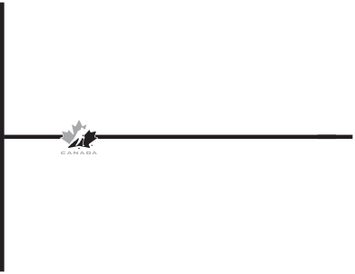 | 
 | 
Once groups have been formed and the teaching stations established, there are a number of basic rules that should be observed:
- players should face away from distractions i.e. spectators, other groups;
- instructors must be visible to all players;
- instructors should try to maintain eye contact with players;
- try to keep players stationary (kneeling in front of the instructors);
- deal with a minimum of teaching points (maximum of two - three at a time);
- formations must allow for a quick and smooth transition to the drill; and
ensure that prearranged signals for movement from one station to the next are known by all players and instructors.

Team Teaching
To ensure a smoothly operating and efficient ice session that involves a number of different stations, a team teaching approach is essential. This requires the designation of a head instructor and a number of assistant instructors to make up the team. Teamwork is a necessity if the concept is to work properly.
The following guidelines are recommended for assistant or group instructors:
- Listen to the head instructor to ensure understanding. If you are not certain of your responsibilities, ask!
- Assist with the set up/organization of any total group drills and be prepared to move quickly into your group activity;
- Provide individual instruction through error correction.
Keep the players well spaced and spread out to ensure drills are being performed correctly and so that there is sufficient room to view possible errors.
Things for the instructor to avoid:
- Skating around aimlessly;
- Shooting pucks;
- Passing pucks with another instructor, and
Talking to players or other assistants while the head instructor is talking or demonstrating.
The head instructor is the one "in charge" of the ice session and has the responsibility of ensuring a smoothly conducted practice. One of his or her prime tasks is to help the assistant instructors carry out their duties. The head instructor should:
- Provide and organize the necessary equipment for your group as required in the lesson.
- Assist in error detection and correction of teaching individuals in your group for short periods
- Briefly take over your group for clarification of a drill or to reinforce teaching points
Be responsible for the timely and efficient conduct of the lessons by the various instructors.

Organization of Equipment and Space
Two of the instructor's most important resources are equipment and teaching aids. Without these, lessons are much less effective, are usually without variety and often become dull and boring. Performance of some skills, particularly at the basic level for beginners, are virtually impossible to perform without equipment and the necessary teaching aids.
The list is virtually limitless, but you should not be without the following:
- pylons
- chairs
- pucks ( 4oz blue pucks and 6 oz black pucks )
- tennis, soccer balls
- spray paint (Water Based)
- markers
- whistle(s)
clipboard(s)
Also nice to have:
- coachmate board
- street hockey nets
rink dividers for reduced ice use

Grouping of Players
At the beginning of the year, one of your first tasks as an instructor, particularly if you are the head instructor, will be to divide the group up into more manageable smaller groups. This will normally take place during and after the first ice session, once you have had the opportunity to view the players' abilities, etc., adjustment to initial grouping may be necessary as the sessions progress.
There are a number of factors to consider in grouping your players:
- the number of assistants you have
- the amount of ice available
- the age range of the players
the level of ability of the players
Ideally, the instructor to pupil ratio should be kept as low as possible (1:1 is perfect but unrealistic!). A good ratio is 1:4 or 1:5; the maximum should be 1:8 or 1:10 for effective control and instruction.
Instructors must also guard against "bombarding" a player with feedback and corrections. Avoid having more than one instructor giving help to the same player.

Exercises:
A. Describe and diagram a system for dividing 35 players of the same age with slightly varying levels of ability into five groups for instructional purposes.

B. Describe and diagram two methods of dividing 32 players ranging in age of 5 and 6 and of varying ability who are on the ice together for a 50-minute period.

Drills and Games
Using a variety of skill drills and fun games and /or relays will go a long way toward making your ice sessions educational and fun. Use these types of activities to break up difficult drills or skills, to relieve boredom, to add variety and to finish off a session on a high note.
Your lesson plans contain a wide variety of drills and games such as:
- British Bulldog
- Red light, Green light
- Scatterball
- Freeze Tag
- Pond Hockey
- Cops and Robbers
- Exchange Game
- Relays
- Rope Skipping
Soccer

Summary
- Adherence to the principles of preparation and planning will ensure that a good lesson is presented.
- Effective use of the ice will result if carefully thought-out teaching stations are used.
- Use of team teaching techniques will maximize use of ice and instructors.
- Sufficient and appropriate equipment is a necessity for a good ice session.
- Grouping of players according to age, ability, space and resources is a decision to be made by the head instructor.
Use of games and fun activities is a necessary part of every lesson.

Module 3 – Leadership / Communication

Leadership
Your primary role in the U7 Program is instructing the basic skills of hockey to beginners. This means that you will be a leader, not only of the children but of the other adults or parents who volunteer to help out. It is therefore important for you to have a basic idea of what is expected of you in the leadership role.
Your leadership role with the players in the U7 Program will be primarily autocratic in nature. This should not be seen as a negative factor. You have superior knowledge, you are the authority figure and you must be in control of the group at all times. In order to maximize learning, minimize opportunities for injuries and accidents to occur and to provide the necessary structure required in the program, this is the leadership style most suited to the head instructor position. Of necessity, your approach to assistants and parents will be more democratic in nature, but you must always be in control of the program and its participants.

Effective Leadership Qualities and Techniques
Some recommended leadership qualities and techniques associated with being a good instructor:

a. Qualities
- be patient
- communicate clearly
- allow for individual differences
- provide a good example
- be willing to listen to suggestions
motivate / encourage players

b. Techniques
- use your influence as a role model effectively
- be yourself — be aware of your own strengths and weaknesses
- attend to individual differences and needs
- encourage independence, responsibility, exploration and growth
master the art of communication

Participation Motives

a. Coach / Instructor's
People become involved in hockey instruction for many reasons. These reasons determine how they interact with their players and the type and amount of impact they have on their players.
To have a positive and lasting impact on the players you instruct, it is necessary that your primary reasons for instructing be consistent with meeting the needs of your players. Your reasons for being involved should reflect the optimal physical, psychological and social development of players. To achieve these goals, you need to be an effective leader, teacher and organizer; encourage and support your players; instruct enthusiastically and express genuine concern for the players' total development and well-being.
As pointed out in the "opening word" above, you significantly affect your players' motivation toward the achievement of their personal goals and the benefits and enjoyment they receive from participating in hockey. Your players' decisions about long-term participation in hockey and sports in general are largely determined by the impact you have on them.
Your reasons for instructing become very important when you consider that the tremendous impact you may have on your players extends well beyond the contact you have with them in hockey.

b. Player's
In the U7 Program, the majority of the players are there because their parents want them there. However, as they begin to develop skills and a knowledge of hockey, they will begin to have their own reasons for participating. These reasons can usually be expressed in the following main categories:
- excellence
- affiliation
- sensation
success
1. Excellence — Players for whom excellence is most important want to be very good at playing hockey. They want to master the skills of hockey and be competent in the sport. These players want to:
- improve their hockey skills
- learn new hockey skills
- excel at hockey
2. Affiliation — Players for whom affiliation is important want to develop and maintain close interpersonal relationships with other players and instructors. They want to be accepted as a member of the group, appreciated by other players and to have fun with other players. These players enjoy:
- making friends
- participating with their friends
- social gatherings
3. Sensation — Players for whom sensation is important want hockey to provide them with exciting sensory experiences. They want to experience novelty and variety, competition and uncertainties as to what will happen next in ice sessions. They like:
- the excitement of close competition in relays and fun games
- doing new drills
- the feelings of skating smoothly and fast
4. Success — Players for whom success is important want to receive recognition for the attainment of skills. They want to receive external or extrinsic rewards and be well known. These players like:
- recognition from coaches
- recognition from parents and spectators
- to receive awards or badges for participation
Excellence and affiliation are the two most important reasons for participation by players in hockey although sensation and success are also relatively important. Although external rewards are an important reason for participation, caution must be exercised by instructors in overemphasizing the use of extrinsic rewards as they may decrease the intrinsic (excellence, sensation) interest of the player for participation. External awards should be provided as a meaningful reward for the attainment of specific, important goals and not as a continuous natural part of participation. Thus, extrinsic rewards should not be given out too frequently or for unimportant reasons.
It is important for the instructor to understand the reasons why players are participating in hockey and provide opportunities for the players to satisfy their reasons for participating. If players are provided with the experiences they are seeking from their hockey participation, then the players will attain improved personal satisfaction from participation and will remain enthusiastic about participating in sport for a long period of time.

Guidelines for Handling Common Situations Encountered by Instructors
Research conducted with athletes shows that if they have instructors who follow the guidelines listed below, the athletes generally:
- enjoy playing more
- like their teammates more
- rate their instructors as more knowledgeable
have a greater desire to continue playing in the future
Look at the guidelines carefully and put a (1) next to the ones you currently use as a part of your instructional style. Put a (2) next to the ones that you need to emphasize.
1. How to be more positive
( ) give a lot of positive feedback
( ) have realistic expectations
( ) give positive feedback for desirable behavior as soon as it occurs
( ) praise effort as much as you do results
2. How to react to mistakes
( ) give encouragement immediately after a mistake
( ) if the player knows how to correct the mistake, encouragement alone is sufficient
( ) when appropriate, give corrective instruction after a mistake, but always do so in an encouraging and positive way
( ) avoid chastising or disciplining the player
( ) avoid giving corrective instruction in a hostile or punitive way
3. How to maintain order and discipline:
( ) maintain order by establishing clearly what is expected
( ) strive to achieve a balance between allowing freedom and maintaining enough structure
4. How to get positive things to happen:
( ) set a good example of desired behaviour
( ) encourage effort, don't demand results all the time
( ) in giving encouragement, be selective so that it is meaningful
( ) encourage players to be supportive of each other and reward them for it.
5. How to create a good learning atmosphere:
( ) set realistic goals
( ) always give instructions positively
( ) when giving instructions, be clear and concise
( ) show the correct techniques when demonstrating
( ) be patient and don't expect or demand more than maximum effort
( ) acknowledge and reward effort and progress
6. How to communicate effectively:
( ) ask yourself what your actions have communicated
( ) encourage two-way communication between instructors and players
( ) be sensitive to individual needs
( ) communicate at the time when the player is most receptive
7. How to deal with individuals who are disruptive:
( ) give them additional responsibilities
( ) appeal to their sense of courtesy
( ) be positive, not punitive
( ) discuss their behavior with their parent(s)
8. How to gain respect:
( ) establish your role as a competent and willing instructor
( ) be a fair and considerate leader
( ) earn the respect of your players...don't demand it

An Instructional Philosophy
An instructional philosophy is built on experience, knowledge and abilities you have acquired over the years. This is based on the development of a personal philosophy of leadership style and of the game of hockey itself. To be able to demonstrate and express a sound instructional philosophy, you must be able to:
- be an effective teacher
- be an effective leader for your players
- be a model of cooperation and fair play
- share responsibilities with players, e.g. picking up pucks and putting pylons away
- develop in your players a respect for other participants
develop self-respect and self-discipline in your players
To have a significant, positive effect on the players you instruct, it is necessary to establish both in your own mind and in your behaviour, a sound, personal instructional philosophy.

Communication

Principles of Effective Communication
Good instruction is a result of clear, concise and meaningful communication. When you influence players, whether it be teaching skills, correcting errors, solving problems, or explaining a new drill, it is done through communication. That's why it is important for instructors to have good communication skills.
As a hockey instructor, it will be necessary to communicate with your players as a large group, as a smaller sub-group (e.g. small group practicing a particular skill) and as individuals. Regardless of the number of players you are communicating with at one time, the same principles apply to communicating effectively.
- Be Enthusiastic — your enthusiasm as an instructor will be contagious. Be the enthusiastic leader of your group. Your enthusiasm will affect your players' enjoyment of the game of hockey.
- Be Positive — interact with your players in a positive manner. Set a good example of desired behaviour. Give constructive criticism frequently and keep your voice at a reasonable and understandable level.
- Be Demanding But Considerate — clearly establish what is expected of the players. Your expectations of the players should be based on their abilities and experiences. Don't expect more than is reasonable and realistic.
- Be Consistent In Communicating With Your Players — communicate in a consistent manner from one situation (explanation of a drill or teaching a new skill) to another and with all of your players (try to avoid playing favourites). Try to keep your temperament on an even keel; this will enable you to communicate more effectively and will enable the players to know what to expect from you.
- Treat All Players As Individuals — it is important to be sensitive to individual needs and allow for individual differences, to show all players that you care for them as individuals. Make an effort to talk to all players individually at each session and get to know their first names as soon as possible.
- Communicate In The Same Manner With Your Child As With Other Players - parents who instruct their own children often put unrealistic expectations on them. If you instruct your children, remember to treat them as you do the other players and don't demand more of them than you do of the others.
Be Patient — particularly with the beginning players, the instructor's best virtue will be patience. Remember that coordination is not yet fully developed, and the activities must be practiced over and over again to effect even the most minor of improvements. Give recognition and praise at every opportunity and patience will pay off.

Verbal and Non-verbal Communication
Communication can be both verbal and non-verbal. "The instructor is in a good mood today" or "The instructor is angry because we didn't do the drill correctly." How did you communicate that? Instructors communicate many messages to players by their actions, facial expressions, use of arms and hands, body position, posture, touching behaviours as well as voice characteristics. Effective communication, both verbal and non-verbal, with your players is affected by how well you use your voice and body.

Verbal
Effective verbal communication, which should complement and support your non-verbal communication, involves good use of your voice. The following are suggestions for using your voice effectively:
- Avoid lengthy and complicated explanations when demonstrating and explaining a skill or drill.
- Use language that is easily understood by the age and skill level of the players you are instructing. Watch for reactions from the players that indicate whether or not they understand your explanations.
- Use a voice that is slightly louder than a normal speaking voice except for the few times it is necessary to project your voice a long distance, (e.g. in an arena). Speaking unnecessarily loud encourages players to make noise themselves and is hard on the nerves of all concerned. Many instructors are able to settle players down by lowering their voices so that close attention is required to hear. Try it!
- Speak clearly and move your eyes about the group of players as you speak. Periodically, look carefully at those who are farthest away from you. Can you see clear indications that they can hear? If there is any doubt, ask them.
Use inflections or changes in the tone of your voice to communicate varying moods (e.g. energetic, patient, serious, concerned).

Non-verbal
Your players often learn their most memorable lessons by watching what you do. The instructor's non-verbal behaviour should reflect what is verbally communicated to the players. Act in a way which shows that you are consistent with what you say. For example, if you ask that your players be punctual for sessions, then your behaviour should reflect this request.
What you communicate non-verbally to your players can be as important as what you verbally communicate. A positive example on non-verbal communication is illustrated by an instructor who acknowledges the successful completion of a skill drill with a smile and a pat on the back. It is important to be aware of the message you are sending to your players.
The following are suggestions for using your body effectively:
- Make an effort to gain eye contact at an eye-to-eye level with all players you are addressing. This will add to the sincerity of your instructions and will help you to determine whether players hear and understand your instructions.
- Move about your players when they are practicing a skill so that they feel you are spending time with each of them.
Use variations in facial expressions (smile often!), positions of the arms, legs and body to change the mood you are trying to convey. Be aware of what these movements and positions convey to your players.

Gaining Attention:
It should now be obvious to you that the correct combination of verbal and non-verbal communication is the most effective method of getting your point across. There are all kinds of lessons being learned by your behaviour, by your actions, by your gestures, by your facial expressions and by the way in which you use your voice - all the ways you communicate to your players. It is therefore very important to try to ensure that your words and actions are as consistent as possible. You can use your voice and body to gain the attention of your players by doing the following:
- have a regular spot or place where you usually begin;
- use a signal (e.g. raised hand, point to yourself, etc.) to indicate attention is needed;
- the whistle should normally be used only to signal for all players to stop what they are doing and look to you for instructions. In the team teaching situation, only the head instructor should use the whistle;
- ask firmly but politely, "May I have your attention, please? We are ready to begin.";
- if all but one or two are paying attention without showing a lot of impatience or annoyance, say something like "thank you", "that's better" or "it is necessary to have your attention so that we can learn this."
- in the extreme case where a player insists on being disruptive, try saying, "this is important Bill, you'll have to pay attention" ...(without sarcasm). In some cases, you may have to add "if you do not pay attention, you will have to leave" or "I will not continue until everyone is paying attention." In rare cases where this fails to work, have the individuals remove themselves from the group and talk to them later, privately;
- be careful not to punish those who have been paying attention after dealing with those who have not been attentive. Continue in a pleasant and positive manner;
make sure you reward people when they do become attentive rather than just singling them out when they are inattentive.

Re-gaining Attention
If at first players are attentive and then their attention begins to wander, first ask yourself;
- am I talking too much?
- have the players been in one position too long?
- am I communicating in a clear and direct manner?
can all players see and hear well?

If the Problem Does Not Lie in the Above
- stop talking, look directly at the inattentive person(s), and move closer to them if possible;
- if this doesn't work, politely but firmly ask for attention using the inattentive person(s) name;
- if several are causing a disruption, consider breaking up the group so they are not together; and
in the final analysis, the best way to keep players' attention is to keep them active.

Effective Listening
One important component of effective communication is listening. How good a listener are you? How much of what your players say to you do you actually hear? Listening to players tells them that you care about them and are genuinely interested in their feelings, thoughts and suggestions.
Good listening is a difficult communication skill to learn well. Like all skills, it takes practice to be a good listener. The following techniques can be used to improve your listening skills:
- Attentive Listening — listening starts by the instructor being attentive to the player. This is demonstrated by your facial expressions and gestures and by being quiet. Eye-to-eye contact with the players, and at the same level, is important. These actions all indicate to the player that you are ready to listen to what they have to say.
- Paraphrasing — you repeat in your own words what it is you think the player said in order to determine if that is what the player meant. Paraphrasing allows you to see if you have a complete understanding of what the player said to you and provides the player with feedback as to whether the instructor interpreted the meaning correctly. Any areas of misunderstanding can then be explained by the player.
- Bridging – you verbally indicate that you are following and understanding what the player is saying by using bridging words such as, "I see", "Yes" and "uh huh".
- Restating — the instructor repeats the last phrase or few words of what the player said without changing anything.
Inviting clarification — the instructor requests that the player clarifies or expands on something that the player has said. In seeking clarification, the instructor words the question to ask about a specific comment made by the player that was not understood. Inviting clarification shows interest in the player by the instructor.
After a session on the ice is a good time to spend a few minutes listening to your players. Get some feedback on areas that went well and areas that the players and/or instructor need to work on.

Questions That Could Be Asked:
- What did you do today that you really enjoyed?
- What was the one good thing that happened today?
- What is the one thing you learned today?
- What did you think you did well?
- What is one thing you would like to do at the next session?
What are you going to tell your parents you did today?

Effective Feedback
Verbal feedback (talking to players about how and what they are doing) gives information which can help them learn and develop in a positive and effective way.
Effective feedback is essential for your players' motivation, learning and self-image. It is an important key to successful instruction, as your feedback can turn a player off or on.

Six Aspects of Effective Feedback
1. Specific NOT General
2. Constructive NOT Destructive
3. Sooner NOT Later
4. Checked for clarity NOT left misunderstood
5. Positive and Informative NOT Negative and Useless
6. Directed at behaviour which is changeable
1. Specific not General
- Specific feedback contains precise information about what the player should try to do in order to solve or correct a problem.
- Example:
- Specific (and effective): "When you turn to your left, you seem to be out of control. Try to lean more toward the centre of the turn and bend your inside leg more."
- General (and ineffective): "You are not turning correctly."
2. Constructive not Destructive
- Constructive feedback recognizes aspects of your players' behaviour and suggest positive steps for improvement. It should deal with observable behaviours. It should not deal with the player's personal characteristics.
- Example:
- Constructive (and effective): "When you pass the puck, you are doing everything correctly, however, when you receive a pass you are letting the puck hit your stick. As the puck arrives, try to draw your stick back a bit to cushion it."
- Destructive (and ineffective): "You pass the puck okay, but you can't receive a pass worth a darn! You're terrible!"
3. Sooner not Later
- Effective feedback is given sooner not later. It is given as soon as possible after the player does something. Your player then has a clearer memory or "feeling" of what has taken place and is in a better position to learn from your feedback.
- Example:
- If you want to encourage shooting the puck in a certain way, you should say something positive immediately after the individual performs the skill. And if your players can "try out" your constructive, corrective feedback immediately after you have given it, they are much more likely to be able to perform the skill correctly the next time they try.
4. Check out for Clarity not Left Misunderstood
- To make sure that your feedback has been clearly understood, check it out with the player.
- Example:
- Ask your players to tell you what they think you said or what they think you want them to do. If they have it right you can reinforce the message ("Yes, that's right"). If they have it wrong, you can clarify the message (That's not what I meant. What I meant was....").
5. Positive and Informative not Negative and Useless
- Effective feedback has two main components. It is generally positive and informative. It reassures the players. It also gives the information needed to correct a problem or error. Negative feedback in itself provides little, if any, precise information on how to correct a problem.
6. Directed at Changeable Behaviour
- Feedback based on this principle helps the player focus on a change which is within reach. It does the player absolutely no good at all to be told by the instructor that he or she is "too small" or not strong enough since this is something the player cannot usually change. Rather, the feedback must focus on some aspect of the skill being performed that can be improved.

To Sum Up:
Effective feedback has three main messages. It tells the individual:
1. “You're OK as a player.”
2. "Here's what you are doing well."
3. "Here's what you need to do to correct your error or improve your performance."
Effective feedback usually provides more information than does negative feedback and if used over time it also leads to better instructor-player relations.

Summary
- An effective instructor
- is enthusiastic
- is positive
- is demanding but considerate
- is consistent
- treats all players as individuals
- communicates in the same manner with his or her own child as with others
- is patient
- Non-verbal communication means how you say something and often means more than what you say.
- Effective use of your voice contributes to clear and effective instruction.
- Communication involves listening.
- Listening techniques include, attentive listening, paraphrasing, bridging, restating and inviting clarification.
- Feedback helps players when it is:
- specific not general
- constructive not destructive
- sooner not later
- checked for clarity not left misunderstood
- positive and informative not negative and useless
- directed at behaviour which is changeable

Module 4 – Teaching Progressions, Teaching Methods, and Skill Analysis
Once you have completed this chapter, you should have a better understanding of:
- the basic teaching progressions to follow and how to plan explanations and demonstrations of skills.
the whole - part - whole method of skills instruction.

Teaching Progressions
Teaching physical skills and technique involves a chain of events. There are four main links in this chain:
- First Link: Select the basic skill to be learned
- Second Link: Plan the explanation and demonstration
- Third Link: Plan how the players will practise the skill
Fourth Link: Provide feedback during practice

First Link: Select the basic skill to be learned
Basic skills are not always simple to learn. In hockey the basic skill is skating but it is a complex and difficult skill. Passing or shooting the puck is actually easier, but skating is the more basic skill.
The instructor has been provided with a set of lesson plans that progresses gradually and systematically through the skills to be learned in the U7 Program, beginning with the most basic and progressing from the simplest to the more complicated skills.

Second Link: Plan the explanation and demonstration
This is the planning you do to organize what you want to teach. Although much of this has been done for you in the lesson plans, it is important you understand the sequence of events to follow in conducting a lesson.
This link contains seven steps:

Step 1
Select a skill and write down why it is important.
Name the skill and if possible, explain briefly and in simple words what the name means — how the skill is used in the sport, and where and when it is used. Keep the explanation simple and brief.
Total time for the demonstration should be of 30 - 45 second duration.

Step 2
Select four or five main teaching points to emphasize.
Each may be made up of two or three closely related ideas. If your participants are young, inexperienced, or have special learning problems, then select only one or two teaching points and keep the points as simple as possible.
Select short, descriptive key words or phrases to highlight the teaching points during the demonstration. Rehearse the demonstration and use the key words until you know them well.
Don't overload the learner by giving too many key words at the same time.

Step 3
Decide if an aid would help.
An aid is a chart, diagram, model of some kind, picture, film or videotape. Do not use an aid unless you feel it will add something important to the demonstration.
Good aids are most useful if they are posted on a wall or bulletin board so players can refer to them after the skill has been taught. They will help them recall details of the demonstration. If an aid is to be used, rehearse with it until you feel comfortable.

Step 4
Select an effective formation.
Consider the number of learners present and decide what formation to put them in where all will be able to see and hear clearly.
These basic formations may be expanded to larger groups by having one row sit or kneel and a second row of players stand behind them. The players should be placed with their backs toward any distractions such as glare from windows or the sun, parents, other groups, etc. For this age group, the most effective formation is probably a semi-circle or open square with all players kneeling down. This eliminates most extra movement and focuses attention on the instructor.
With large groups it is important to try to have players in a formation as close as possible to the one from which the practicing of the skill will begin. Otherwise there will be unnecessary confusion and lost time re-arranging groups when the demonstration is over.

Step 5
Decide on what view or views players should see.
Mentally check out the best angles for viewing the demonstration. Plan to repeat the demonstration as many times as necessary rotating 90° or 180 ° each time to ensure that all players see it from the best angles. Remember, total time for the demonstration and explanation should be no more than 45 seconds from beginning to end. If it goes longer, it will have been repeated too often or too much detail will have been given.

Step 6
Decide on who demonstrates.
Having decided what is to be done, decide on who should demonstrate. Being asked to demonstrate is rewarding. Many members of the group should be called on to do it.
Instructors often demonstrate a skill several times themselves and then ask a player to step out and try it under their guidance. In the case of simple demonstrations, use an ordinary member of the group - it does not have to be a top performer. Most players identify with average performers and learn best from them. Beginners do not remember fine details to start with and they sometimes find the best performers discouraging to watch.
Some individuals do not like to get up in front of their peers to demonstrate. An instructor should respect these individuals' feelings by asking them before the practice if they would mind taking part in the demonstration.

Step 7
Call for questions to conclude.
To make sure that players understand, ask if they have any question. Answer those, which are related closely to the skill, but politely refer questions not to the point to a later time to avoid getting sidetracked.
All questions should be answered with respect, even if they have been covered during the demonstrations. If players are shy in the beginning, pose questions yourself and answer them yourself.
U9 athletes have difficulty doing a sport skill if they don't know exactly what it is supposed to look like. Check to see that what you describe is what they picture in their minds when they are trying to do it.

A Word of Encouragement
At first, these steps will take quite a bit of time to follow. But if you use them frequently you will soon be able to go through them with only the briefest of notes.
Experienced instructors recall details of a demonstration and how to stage it simply by recalling the name of the skill.

Third Link: Plan how the players will practice the skill
The next link in the teaching chain is organizing a group to practice a skill that has been demonstrated. This is quite separate and distinct from planning and organizing the demonstration. The following steps will help you to plan effectively:

Step 1
Take stock of the practice environment.
Answer the following questions as a basis for your planning:
- how many players are there?
- how much area is there available to work in?
- how much fixed equipment is available?
- how much small equipment is available?
- what special dangers exist in the practice area that must be guarded against?

Step 2
Maximize activity.
The object is to use as much of the space and as much of the time as possible. Plan the practice activity so there is as little unnecessary waiting time as possible.

Use your best judgement to answer the following questions in planning the practice activity:
- will it be best to start participants working alone, in pairs or in small groups?
- do learners need to be moving or can they practise in one place? If they are moving, where should they start from so there will be enough clear area to move in?
- is the skill to be practised of a type that players should be paired off or grouped by size, experience or aggressiveness in order to minimize chances of injury and equalize competition among and between learners?
- will players have to be grouped and take turns sharing because there is not enough area or fixed or moveable equipment?
- how can you make the groups as small as is practical and as active as possible?
- how can dangers in the area be removed, covered or otherwise decreased or avoided by careful placing of players and their patterns of movement?
Some breaks in activity can be constructive — here are a few reasons:
- if time is needed to rest in vigorous practices
- when space available is too small for all to be active
- when the amount of equipment is limited
- if it is not safe for everyone to be active at the same time
- if time is required to correct, re-teach or give further instruction

Step 3
Plan to move learners into practice activity quickly.
Where possible, the formation used to observe the demonstration should be as much like the practice formation as possible. If groups or squads are to be used regularly, then players should be assigned to specific groups. Membership of the groups should be changed from time to time.
The instructor must take care to maintain the attention and control of learners during the time between the demonstration and the beginning of practice.
Require attention, give simple, clear instructions and plan simple, efficient method of distributing equipment if that is necessary.

Step 4
Use clear, precise instructions.
As soon as players are in position ready to begin the practice of the demonstrated skill, explain simply what is to be done. Watch their faces for signs that they do understand or are puzzled. Re-explain in the same or different words as seems necessary.
Use simple key words or key phrases to drive home the main points of instruction. Repeat one or two key words at appropriate times during and after demonstrations.
Carefully point out any special safety precautions and pause to see that your orders have been heard and understood.

Step 5
Check and correct the practice pattern first, then check technique.
When practice begins, your attention should be on the pattern of activity. That is, are groups spaced properly so they have enough room? Are they skating far enough and turning at the place you asked them to? Are safety precautions being observed? Did they understand the instructions?
If any of these things need attention, correct them as the players practice. If this is impossible, stop the group, get their attention and make corrections.
Once the practice pattern is well established, then begin to check technique and details of the skill as players perform. This is an extremely important point. Get the practice pattern going smoothly first. Then and only then, begin to check the technique of players. Stand or move around so you can see or scan the whole group. If all is going well, let them proceed for a while.

Fourth Link: Provide feedback during practice
Feedback during learning involves feeding back information to the players about their efforts to learn. It serves three important functions in learning:
1. As a guide to improvement
2. As a measure of progress
3. As reward or discipline

1. As a guide to improvement
- Learning skills can be very confusing. There are many things to think about. First the player needs to know what is being done correctly so he or she will know what parts of the skill are under control. This is not a matter of being nice to the learner by being positive to them. This is based strictly on sound principles of skill learning.
- If players are not clear on what parts of the skill are being done correctly they may change some of those things for the worse as they try to correct other parts of the skill.

2. As a measure of progress
- If an athlete knows that his/her list of questions about how to do a skill is getting shorter it will be easy for him or her to recognize improvement.
- Often a player will recognize increased skill as a new feeling of naturalness and smooth action that replaces stiff, unnatural action ("it feels much better now") and this is another kind of important evidence or improved quality.

3. As reward or discipline
- While knowledge of improvement rewards us, so does approval or recognition, words of encouragement from people important to us, family members, friends and instructors in particular. "Well done!", "yes, excellent," "Good work", "Charlie, I'm proud of you".
- Physical discipline is not acceptable nor is extra strenuous, physical work an advisable form of discipline.

Teaching Methods
There are two approaches commonly used in teaching simple skills: imitation, and demonstration/explanation followed by practice and feedback.

The Imitation Method
Simple imitation is often the best way for players to learn. It requires them to focus on what is to be imitated or copied. "Watch this... Try it". Often the imitation is as accurate as it needs to be. You should then confirm it: "Yes. That's it. Now remember that." If necessary, have it practiced several times.
When minor corrections are required point them out in a clear, matter-of-fact way. If players have trouble picking up the correct action or movement then you should realize that, for some reason, it is not as simple as expected.

The Demonstration / Explanation / Practice / Correction Method
This method is used extensively. It involves these steps:
- Demonstration first with minimal explanation: "Watch this. Be careful to stand like this, then shoot the puck. Try it."
- Allow for practice. Observe carefully, looking for correct features and common errors.
- Provide feedback while practice continues if possible. If you must, stop practice and confirm correct actions and if necessary make suggestions to correct errors.
Allow further practice and correct in more detail, if necessary

Summary
There are four links in teaching skills:
- First Link: Select the basic skill to be learned.
- Second Link: Plan the explanation and demonstration
- Step 1 — Select a skill and write down why it is important.
- Step 2 — Select four or five main teaching points to emphasize.
- Step 3 — Decide if an aid would help.
- Step 4 — Select an effective formation.
- Step 5 — Decide on what view or views players should see.
- Step 6 — Decide on who demonstrates.
- Step 7 — Call for questions to conclude.
- Third Link: Plan how the players will practise the skill.
- Step 1. — Take stock of the practice environment. Answer the following questions as a basis for your planning.
- Step 2. — Maximize activity
- Step 3. — Plan to move learners into practice activity quickly.
- Step 4. — Use clear, precise instructions.
- Step 5. — Check and correct the practise pattern first, then check technique.
- Fourth Link: Provide feedback during practice.
- As a guide to improvement
- As a measure of progress
- As reward or discipline

Skill Analysis
As an instructor, one of your most important tasks is telling your players whether or not they are performing a skill using the correct techniques. You should be capable of telling them the specific correction technique which will improve their skill.

What is Skill Analysis?
An instructor is a judge of hockey skill. To be a good judge of these skills, the instructor must be able to:
- break complex skills down into simple parts.
- separate the good parts of technique from the bad parts.
- focus on the important parts of technique and not be distracted by ones that are less important.
put the whole technique back together to form the whole skill.

Principles of Movement
Experts have discovered ways to assist you in developing your skills in the analysis and correction of performance. These experts are sports scientists who have applied some of the basic ideas of physics to the analysis of sports skills and have determined that:
"There are a few principles of movement that explains how all sports skills are done."
These principles are ideas that are true for hockey as well as for other sports. They explain how the different parts of the body should be used in skating, shooting, stickhandling, passing and all the other skills in hockey. If you can understand and apply a couple of these basic principles, you can become a hockey skill analyst.
Before skill analysis was used in sport, coaches tried to:
- memorize all the details of each skill,
- correct errors in performance by demonstrating a series of poses for players, and
use expressions such as "skate hard", "you're not trying", "put more wrist into your shot" which were not specific enough to give the player something to change.
These methods did not work effectively.
All the principles of movement are based on how forces are made by or act on the player's body. The action of the muscles of the body produce forces at the joints that in turn produce movements of certain speed, acceleration or momentum and these properties of a player's movement in turn determine the quality of the skill.
The two basic principles of movement that will be covered in the U7 Program are:
- Principle #1 — Use all the joints that can be used (summation of joint forces).
Principle #2 — Use each joint in order (continuity of joint forces).
Both of these principles apply specifically to power skills such as skating, passing and shooting where the player is trying to create as much force as possible.

Principle #1 "Use all joints that can be used".
Since most sport skills are done by using the muscles around several joints, the first principle tells us how many joints should be used.
The forces from each joint must be combined to produce the maximum effect. This is best done when all joints that can be used are used.
This principle means that every joint that could be involved in a skill movement does play a role in either contributing to good performance or hindering performance.
The important thing to remember is that every joint must be used to get the most speed, power of acceleration out of the movement.
Examples:
Skill | Fault | Violation of Principle #1
skating | stiff-legged | not using knee and/or hip joints
shooting | weak shot | not using elbow and/or shoulder joints
Exercise:
Pick out some common errors in beginner's hockey skills that may be caused in part by leaving out a joint that should be used.

Principle #2 "Use every joint in order."
When several joints are used in doing a skill, their sequence and timing are important.
Movement should begin with the large muscle groups and move out through the progressively smaller ones. This movement through the body must happen in proper sequence, without any breaks in flow if the skill is to be performed correctly.
Watching players performing skills, your job is to ask two questions:
- Did they use all joints they should have used?
Did they use the joints in the right order without gaps or breaks in the movement?
Use the chart to help you answer these questions.

Correction Methods
If your players violate either principle, i.e. they don't use a joint which they should or use a wrong sequence or have gaps in joint movement, how do you fix it?

There are two main correction methods:
1. check for preliminary movements.
2. teach a whole-part-whole.

1. Check for preliminary movements.
Have you ever noticed that before you jump up, you have to crouch down?...before you skate forward your leg has to go back?...before you shoot a puck you have to "cock" your wrists? Most preliminary movements are opposite to the pay-off movements that follow. Muscles are arranged in opposite pairs — so preliminary movements help stretch the muscles that do the pay-off movements. In this movement, the stretched muscles contract or shorten. If your players are not using every joint, you can tell them what preliminary movement is missing.
Example:
An instructor is teaching a group of beginners how to skate. He or she notices that one young player is having difficulty getting started, that the first two or three strides are ineffective in producing forward motion. The instructor calls the youngster over and explains in simple terms that the push-off must be done at an angle (preliminary movement), that the hip, knee and ankle must all be used in sequence (pay-off movement) to produce the proper stride. The instructor then watches the youngster practice, giving more feedback as he or she progresses.
Example:
Try to define another situation where preliminary movements are a key to skill analysis.
To correct a violation of the "use all joints that can be used" principle, you adjust the preliminary movement so that the missing pay-off movements must be done. Remember, the preliminary movements are opposite to the pay-off movements.
The following exercise assists you in identifying some preliminary and pay-off movements from hockey so you can put these ideas to work.
Exercise:
Select two hockey skills and using the chart, identify the preliminary movements and the subsequent pay-off movements for each skill. Try to explain (demonstrate if you wish) how the movements are done.
Skill | Preliminary Movements | Pay-off Movements
#1
#2

2. Teach whole-part-whole.
Since these types of errors involve either the wrong sequence or timing of the parts of a skill, you have to break the skill down into its parts, practice those parts and then put the whole skill back together again. The technique is called whole-part-whole teaching.

Example:
An assistant instructor is teaching passing to young players. The instructor spots one player who cannot seem to get the necessary distance on any passes. The instructor feels that the proper wrist action and follow-through are not being performed. The instructor stops the player, demonstrates the total passing action (whole), and then has the player practice first the wrist action without the puck (part), with a puck against the boards (part), then with the full action with more emphasis on the follow-through (whole). More practice and constructive feedback follow.
The skill evaluation checklists in the manual will be the most important tools for skill analysis you are given as they will give you the key points to look for. All of the skills taught in the U7 Program are listed in Annex A: Key Instructional Points.

Summary
- There are a few principles of movement that explain how all sport skills are done.
- Principle #1 is — use all the joints that can be used.
- The forces from each joint must be combined to produce the maximum effort. This is best done when all joints that can be used are used.
- Principle #2 is — use every joint in order.
- Joints which have large muscles and are in the centre of the body should be used before joints that have small muscles and are found at the ends of the arms and legs. The resulting motion should be fast and continuous.
- To judge a sport skill, the instructor must be able to break down complex skills into simple parts, separate the good parts of technique from the bad parts, find a way to correct technique and put the whole technique back together.
- To correct skill errors that violate the principles:
- Check for preliminary movements.
- Teach whole-part-whole.

Module 5 – Safety
Once you have completed this chapter, you will have a better understanding of these key aspects of safety in hockey:
- The injury prevention techniques you can use
- The reasons for and the content of warm-ups
- The safety precautions to follow in on-ice sessions
- The way to choose and use each piece of protective equipment

Injury Prevention
Virtually all injuries sustained by U7 Program participants will be caused by lack of skill and will be minor in nature. As an instructor, you should strive to minimize the chance of injury occurring, particularly injuries that could be caused by faulty equipment or unsafe facilities.
If we can identify the causes of injuries, we can think of ways to reduce or prevent them. The following is a list of potential injury prevention techniques you can use.
- All instructors should have a basic knowledge of First Aid. If you do not, you should attempt to take a basic first aid course as soon as possible.
- Get information on the health status of your players. This can be done by:
- getting a health history from parents
- getting reports on previous injuries
- health insurance number
- Try to anticipate problems that could arise on the ice:
- check out facilities and equipment
- see On-Ice Safety on page 34
- Don't force players who have been injured back too soon.
- ensure the player demonstrates normal flexibility, strength and absence of pain before returning
- Be familiar with emergency procedures in the arena, the location of a fracture board, stretcher, first aid kit and telephone.
- Take care of minor injuries quickly so they don't become major ones.
- Check your players' equipment to see that it is appropriate, that it fits and that it is kept in good repair.

Warm-up
An important aspect of every prevention program is a proper warm-up. There are three main reasons for warm-ups:
- to stretch the muscles, tendons and ligaments, particularly those that are going to be used.
- to heat the body, particularly in the deep parts like the muscles and the joints.
- to prepare for what is to follow by stimulating them mentally and physically.
How should we warm-up?
Two basic kinds of exercise make a warm-up:
- stretching exercises
- vigorous exercises

On-ice Safety
During ice sessions you have a responsibility as an instructor to be prevention minded about injuries. The following safety precautions should be observed:
- have players learn how to fall.
- ensure players stop at least five - ten feet from the boards when performing skills or drills
- ensure properly fitted protective equipment is worn at all times
- the instructor should consider wearing a helmet while on the ice
- do not permit any "horse play"
- care should be taken to ensure that shooting drills are conducted in as safe a manner as possible
- remove immediately any foreign materials on the ice
- ensure all doors to the ice surface are closed prior to players starting any drills
- do not use dangerous materials to divide up the ice surface, e.g. bare ropes stretched across the ice

Protective Equipment
The following is a summary of the important points raised regarding each piece of equipment. It is the responsibility of every instructor to ensure that each of his or her players is adequately protected and that parents are advised of the necessity to wear properly fitting and approved equipment.
- Athletic support and protective cup
- must completely cover and protect genitalia
- purchase according to correct waist size
- Garter belt
- must be properly adjusted to hold up hockey socks
- purchase according to correct waist size
- Shin pads
- must properly protect shin bone and knee cap
- shin and kneecap should be made of hard plastic with suspension in shin and extra padding in knee
- space between knee cap and shin section must be flexible yet well protected
- when kneecap is properly fitted over knee, bottom of pad must reach yet not extend beyond top of skate
- Pants
- pants must protect the front and side of the thigh, tailbone, hip and kidney area. Unless they are properly fitted, they will not provide this protection.
- Girdles
- designed to fit snugly to the body
- padding must protect all areas noted above (pants)
- girdle should not shift around when player walks
- bottom of girdle legs should touch top of kneecap when standing
- Shoulder pads
- constructed with hard caps for shoulder tips, plus flexible shock absorbing material over the upper arms, chest and back
- advisable to have adjustable straps on arms and body to ensure proper fit
- Elbow pads
- must cover the complete elbow joint with good shock absorbing material
- when fastened properly, should extend from shoulder pads to the gloves, and not be able to slip
- Helmet
- must be CSA approved
- if adjustable, must fit properly and cover the forehead, temple and base of the skull
- straps must be fastened
- available in different sizes; and must not move around the head
- Face mask
- must be CSA approved
- available in clear plastic and wire cage
- must be securely fastened to the helmet so that it will not make contact with the face
- Gloves
- must be well padded over fingers, thumb and back of the hand, yet flexible to allow movement
- should be hard fiber protection covered with shock absorbing material over wrist and forearm
- glove must extend up arm to the elbow pads
- gloves must fit snuggly, yet be large enough so that the hand and wrist movement is not hindered
- Skates
- must provide good support and protection in toe, heel and Achilles tendon areas
- toe caps must be constructed of hard plastic
- counter should also be constructed of plastic in order to provide long lasting support
- Stick
- must be of proper length and life
- should be taped on blade and upper handle
- ensure a proper shaft size for the player (should be smaller for younger players)

Annex A: Key Instructional Points

Pyramidal Definitions of Terms

Strategy
The selection of team play systems in order to impose upon the opposition, the style of play and tactics which will build on the coach’s, team’s strengths and neutralize those of the opponent while at the same time taking advantage of the opponent’s weaknesses.
For example: when opponent’s defensive players have weak puck handling skills, the strategy might be to shoot the puck in and use a 2-1-2 aggressive forechecking system.

Team Play System
A pattern of play in which the movement of all players is integrated in a coordinated fashion in order to accomplish an offensive or defensive objective (e.g. 2-1-2 forechecking system).

Team Tactic
A collective action of two or more players using technical skills and / or individual tactics in order to create an advantage or take away the advantage of an opponent (e.g. 3 vs. 2).

Individual Tactic
Action by one player using one or a combination of technical skills in order to create an advantage or to take away the advantage of an opponent. A tactic may be classified as offensive or defensive (e.g. 1-on-1 offensive fake and driving to the net).

Technical Skills
The fundamental skills that are required to play the game (e.g. skating, shooting, passing and checking).

The Importance of Skating
Skating is to hockey what running is to soccer. Skating is the foundation upon which all other skills are built. The level of performance attained by a player in passing, shooting, checking and stickhandling are directly related to one’s skating ability. The time spent improving a player’s skating is a worthwhile investment due to the carryover value to the many other aspects of the game.
Upon completion of this material, you will be better prepared to understand and describe the key elements of skating:
- Basic Stance
- Skate Edges
- Forward Start
- Forward Skating
- Forward Stop
- Forward Turn
- Backward Skating
- Backward Turn
- Puckhandling
- Passing
- Shooting
- Deke

Basic Stance
The basic stance, or “ready” position, permits a player to move in any direction from a solid base of support. It is particularly effective during face-off alignments or in front of the net when screening the goaltender or waiting for a rebound. This position is also used when executing many of the basic skills such as passing, shooting and checking.

Key Points
- Feet are shoulder width apart, pointing slightly outward.
- Knees and ankles are flexed at approximately 45°.
- The upper body leans slightly forward (approx. 45°) with the weight of the body on the balls of the feet.
- The shoulders, knees and toes can be joined by a straight line when in the basic stance.
- Head up, eyes looking forward.
- The stick is held with both hands, blade flat on the ice and slightly to the side of the body.

Proper Stance
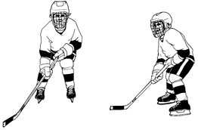
1 Skates parallel and shoulder width apart.
2 Point toes straight ahead.
3 Bend knees until they are in line with toes of the skates.
4 Body leaning slightly forward.
5 Head up.
6 Two hands on stick; stick close to ice.

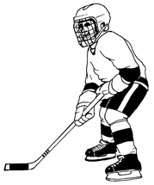
Balance
Balance is a basic skill required for the development of all hockey skills. A player who has developed balance can puckhandle, pass, and shoot much easier.

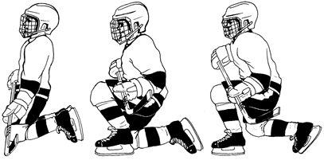
Getting up from Ice
1 Always come to the knees.
2 Don’t place hands on the ice. Keep both hands on the stick
3 Slide one leg forward so that the blade of your skate is on the ice and follow with the other.

Moving Sideways
1 Players start from basic stance.
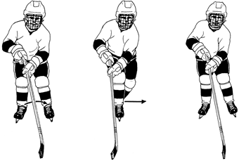
2 The body moves at right angles to the direction of movement. Do not turn body in the direction the player is going.
3 Steps must be taken flat-footed.
4 Keep the stick out in front of you.
5 Walk slowly at first. As the players pick up the drill, speed up the tempo.
6 Progression:
a Put the right skate in front of the left skate.
b Take the left skate from behind the right skate and place it back in the normal stance position.

Skate Edges
Understanding the basic edges of a skate blade is important to teaching skating. The skate blade has two edges: inside edge and outside edge.
Although both skate edges play a role in propulsion, the inside edge is primarily used for “pushing” or “driving”.
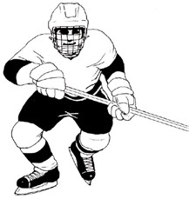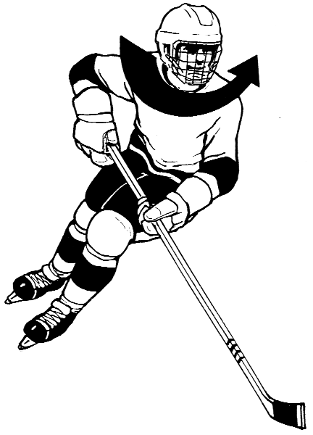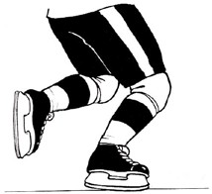
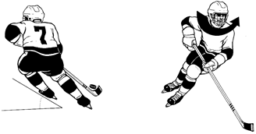
The outside edge, although sometimes used for propulsion purposes, is primarily used for turning and stopping. The accompanying figure illustrates the use of both edges during a turn.
Weak skaters have control of only two edges while average skaters have mastered three edges. In both cases, individuals should strive for control of all four edges in order to become proficient skaters.

Forward Start
The ability to start quickly should be one of the first skating skills mastered by young hockey players. Three types of forward starts are used, depending on the game situation: T, front and crossover starts.

Key Points
- Basic stance is the starting position.
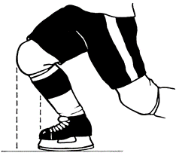
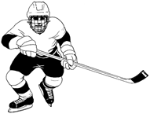
- Centre of gravity is shifted forward with the body weight placed on the inside edge of the drive skate.
- Body weight is placed over the drive leg which is rotated outward at an angle of approx. 90° from the player’s chosen course.
- As the number of strides increases, the player takes progressively longer strides, pushing more to the side rather than to the back.
- First 3 or 4 strides are short and quick, without gliding.
- The drive leg is vigorously extended at the hip, knee and ankle.

T Start
The “T” Start is used when a player is stationary and knows beforehand the direction one wishes to travel. This is the case in some face-off situations. It is also used to teach beginners how to start as it is easier to master than the front start.
The primary difference between the “T” Start and the front start is in the positioning of the skates.
1 Both legs are flexed slightly.
2 The driving leg is positioned at a 90° angle to the desired direction of travel, thus creating the “T” position.
3 The start is initiated by a thrust of the driving leg (inside edge).
4 Without any gliding motion, the lead foot is raised and rotated outward ready to perform another driving motion.

Front Start
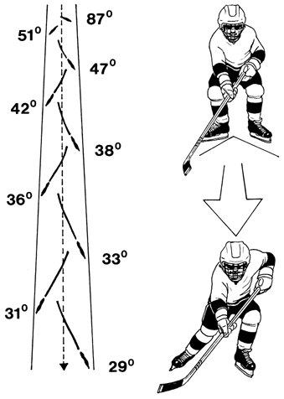
1 Players in basic stance, skates shoulder width apart, knees flexed, and back straight.
2 Turn heels in to make a “V” with your skates, while leaning slightly forward. This puts weight on front part of blades.
3 Drive off with either the right or left skate on the first stride and alternate legs with each stride. First stride with each foot is a short driving stride. More like running.
4 Skates are low to the ice for quick recovery.
5 Next two strides are longer. Angle of the blade nears 35°- 40° at about the third or fourth stride.
6 Gradually straighten up as speed increases to the maximum.
7 Should be in full stride after the first six strides.

Front Start with Crossover
1 Player is sideways to the intended direction with the skates slightly closer together than in a basic stance position. Feet shoulder width apart, knees bent, and weight on the balls of the feet.
2 The head and shoulders are rotated in the desired direction while the body lunges forward driven by the extension of the outside leg. (inside edge) followed quickly by the inside leg (outside edge).
3 The outside leg crosses over in front of the inside leg and is forcefully brought down on the ice at an angle as close to 90° as possible to the intended direction. The stride is short and as close to the ice as possible. Land on the full blade.
4 Player is now in a front start position.
5 First three - four strides are very short and choppy.
6 As speed builds up the stride is lengthened.
7 Practice move in both directions.

Crossover Start
A crossover start is used when a player wishes to start rapidly after a two-foot stop. It is also used when a player is sideways to the direction one wishes to go. It can be defined as a front start preceded by a crossover action of the leg.
1 Skates are slightly closer together than in the basic stance.
2 Skates are parallel and perpendicular to the desired direction of travel.
3 The head and shoulders are turned in the desired direction.
4 The body leans towards the desired direction.
5 After the crossover, the outside skate is placed at a 90° angle to the desired direction.
6 Perform only one crossover to assume a forward starting position.

Forward Skating
The efficiency of the skating stride depends on applying a few fundamental principles and optimum development of the muscles used in skating. Careful attention should be paid to the following key points when teaching forward skating.

Key Points
- Basic stance is the starting position.
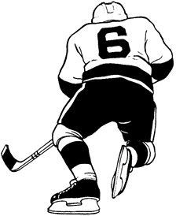
- Power is derived from a full and vigorous sequential extension of the hip, the knee and the ankle in a lateral thrust (to the side and not to the back as in the initial stroke).
- The knee of the gliding leg must be well flexed extending beyond the toe of the skate in the gliding state.
- The weight of the body is transferred over the striding leg at the beginning of each stride.
- Recovery is executed in a circular motion, with skate low to the ice, passing under the centre of gravity.
- Shoulders should be kept perpendicular to the intended direction with the muscles of the upper body relaxed.
- The stick can be held in one or two hands depending on the game situation. The shoulder and arm muscles should be relaxed.

Gliding on Two Skates
1 Take a few skating strides to gain momentum.
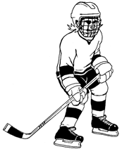
2 Assume the basic stance.
3 Common errors:
a Ankles cave inwards or outwards.
b Knees press in towards each other.
c Legs are straight.
d Body is twisted.
e Upper body leans too far forward.
f Head is looking down at the ice.
g Not having two hands on the stick.
h Stick not close to the ice.

Gliding on One Skate
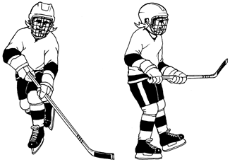
Basic principle in skating is that one foot must be under the body’s centre of gravity at all times. Skating involves being on one foot or the other most of the time. It is therefore essential that hockey players learn to balance and glide on one foot.
1 Take a few skating strides to gain momentum.
2 Glide on one foot.
a Keep the blade of the supporting skate flat on ice, not on the edges.
b Maintain the basic stance on the supporting leg.
c Glide in a straight line.
3 Common errors:
a Basic stance.
b Weight is not being brought forward on supporting leg.
c Player is on the inside or outside edge of skate.

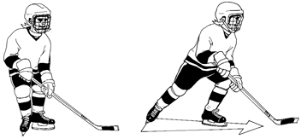
T-Push
1 Point the front skate in the direction of movement.
2 Place the back skate slightly behind the front skate, thus forming a “T”.
3 Keep the whole blade flat on the ice. Keep weight on the back skate.

Scooting
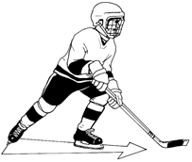
Scooting involves T-push, helps to improve pushing power and leg extension.
1 Place the left skate behind the right skate, forming a T-push with left skate.
2 Push down and out with left leg, fully extend the left leg and glide on right skate.
3 Bring left skate quickly up into T-push position behind right skate before the next push is made.
4 Practice using both skates.

Striding in Forward Skating
Power is developed by taking fast, short strides. As speed increases, long and less frequent strides may be taken to maintain speed.
1 Stride starts with feet close together and all weight on the pushing foot.
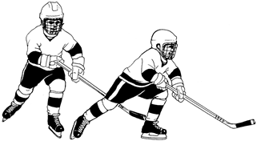
2 Foot is turned 35°- 40°, and the push is to the side and down, pressing the blade deeply into the ice.
3 As pushing foot is forced out to the side, the knee of the other leg is pushed forward.
4 Push skating leg down and out as far as you can, until completely extended including ankle and foot extension to tip of toe.
5 When stride is finished, the weight is transferred to the forward foot and pushing foot comes slightly off the ice.
6 Knee of back leg is pulled forward with knee bending and pulled close to the gliding foot. Foot is kept close to the ice.
7 You are now ready to start the next stride with the opposite foot.

Forward Stop
For safety reasons, the stop should be one of the first skills taught. Use the various lines painted on the ice as stopping points to eliminate any unfortunate accidents which may occur close to the boards.
Stops are essential in avoiding checks, shaking off opponents or changing directions. The key forward stops are one o’clock - eleven o’clock stops, front-foot stop, and two-foot stop.

Key Points
1 Turn the skate at a 90° angle to the direction of motion with a rotating action of the hips.
2 There should not be any upward extension of the body before rotating as it then becomes difficult to apply sufficient pressure to the blades.
3 The knees are well bent going beyond the toes of the skates at the beginning of the stop.
4 The skates are staggered, 6 – 8 inches apart. The inside skate is slightly beyond the outside skate (toe to arch).
5 To stop sharply, weight should be distributed as evenly as possible over both skates, and pressure should be exerted on the front part of the blades while extending the legs vigorously – inside skate (outside edge) and outside skate (inside edge).

One O’clock - Eleven O’clock Stop
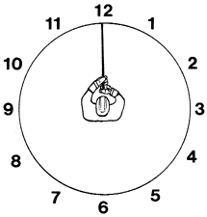
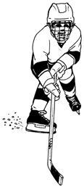
One o’clock refers to pushing out with right skate towards one o’clock. Eleven o’clock refers to pushing out with left skate towards eleven o’clock.
1 A stop in which the player remains facing forward.
2 Glide on two skates in basic stance.
3 Turn heel of right skate out and the toe of right skate in. Push skate out and down towards one o’clock.
4 Keep weight on the ball of your foot as you stop.
5 Keep knees bent and the back straight.

Front-foot Stop (inside edge)
Technique is essentially the same as the two-foot stop, except the inside leg is held back slightly above the ice.
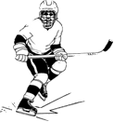
1 From a regular skating stride, snap the skate of the front leg at a 90° angle to the direction of motion. Initiate with a rotating action of the hips and shoulders.
2 The weight of the body is on the front leg.
3 Pressure on the ice is applied on the inside edge and on the front part of the blade while extending the leg vigorously.
4 Inside leg is slightly off the ice ready to initiate a new movement.

Two-foot Stop
Will stop more quickly than a one o’clock or eleven o’clock stop.
1 Glide on both skates as you approach the stopping point.
2 Basic stance — head up, knees bent, back straight, and feet shoulder width apart. Must turn sideways to the direction of travel, by turning the body to a right angle to the direction of motion. Turn initially to just the strong side.
3 Begin the stop by turning the shoulders first with the hips and legs following.
4 Turning the hips swing the outside leg into braking position. The inside leg acts as a pivot while turning into a braking position. Skates are shoulder width apart with the inside skate slightly ahead of the outside skate. The weight is equally distributed on both skates.
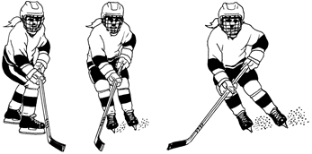
5 Extend the legs vigorously while exerting pressure on the front part of the blades. We are using the inside edge of the outside skate and the outside edge of the inside skate, especially the inside edge of the lead skate.
6 Keep head and shoulders straight.
7 Keep two hands on the stick.

Forward Turn
To change direction, turns are more energy efficient than stops and starts. It is essential that individuals learn to turn equally well in both directions because of the nature of today’s game (e.g. flow and rapid transition). The key forward-turn skills are the glide turn, tight turn, sharp turn, forward crossover turn, crossover pumping, and reversing direction.

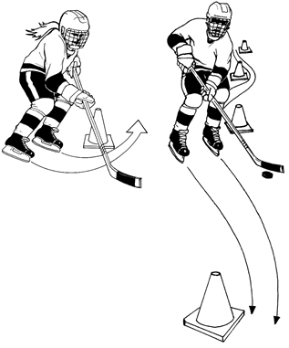
Glide Turn
1 Skates are shoulder width apart.
2 Lead with the inside skate.
3 Head and shoulders initiate the turn.
4 Bend knees and lean inside.
5 Rock back slightly on the heels.
6 Follow the stick.
7 Perform the drill in both directions.

Tight Turn
Permits a player to change direction in a very limited space while expending the least energy. Must be mastered to both sides.
1 Stop skating and let yourself glide into the approach.
2 Head up, knees bent, and feet shoulder width apart.
3 Place the skate on the side you wish to turn directly in front of the other, heel to toe.
4 Turn your head and shoulders in the direction you want to go and bring your arms and stick to the same side.
5 Lean well from the hips down inside the half circle that your skates will trace on the ice.
6 Weight should be as evenly distributed as possible on both skates. Pressure is on the outside edge of leading foot and inside edge of following foot.
7 Skates should be close together and centre of gravity ahead of skates, in order to be able to crossover after the tight turn and to accelerate rapidly.
8 Do not sit back on your blades.
9 Once skates have traveled a complete half-moon on the ice, player executes a crossover start by bringing the back leg over the front leg in order to accelerate out of the turn.

Sharp Turn
The sharp turn is one of the most difficult techniques to master, but it is also one of the most useful. The player must execute a change of direction of 180° in a very limited space while attempting to maintain the highest possible speed.
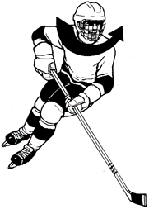
A glove, a puck or a face-off spot on the ice are good markers for teaching sharp turns. Avoid teaching sharp turns around tall cones as it prevents players from leaning well into their turns.
1 The skate on the side of the desired turn is placed slightly ahead of the other skate.
2 The head, shoulders, arms and stick are turned in the desired direction of travel.
3 The body leans significantly in the desired turning direction; the upper body leans slightly forward.
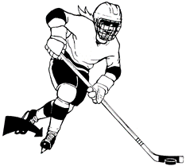
4 The outside leg then crosses over the inside leg in order to accelerate out of the turn.
5 Weight should be placed on the outside edge of the lead foot and the inside edge of the back foot.
6 For a sharper turn, more weight will be placed on the back of the blades.
7 The amount of knee bend will be determined by the desired quickness of the turn.

Forward Crossover Turn
Forward crossovers are used to change direction while attempting to gain speed.
1 Rotate the head, shoulder, arms and stick in the desired direction of travel.
2 The body leans well into the circle with the trunk bent slightly forward.
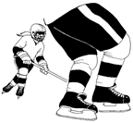
3 The weight is transferred from the inside to the outside leg which now thrusts by an extension of the hip, knee and ankle.
4 To increase speed, bend the knees as much as possible before extending the driving leg
5 Body thrust is alternately carried out by both legs, while the body weight is kept above the drive leg.
6 Following a vigorous extension of the hip, knee and ankle of the inside leg (outside edge), the outside leg (inside edge) crosses over the inside leg.

Crossover Pumping
Used to keep speed or to increase speed while skating on a curve.
1 Skating on the circles.
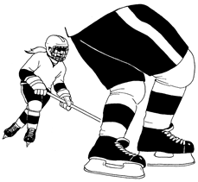
2 Push outside skate out toward the side keeping the blade in contact with the ice until the leg is fully extended.
3 Push down on the ball of your foot at the end of the push so that you are using your ankles to get that little extra push from each stroke.
4 Lean into the circle from the waist down by pushing your hips into the circle and keeping your inside shoulder up.
5 After extension in step 2, swing your outside leg over the skate and place outside skate parallel to the inside skate.
6 The inside skate then pushes to full extension outward under the body (using outside edge).
7 When fully extended, return it quickly to its original position under the body and beside the outside skate.
8 Repeat the sequence in a continuous manner, pushing with equal force with both strokes.
9 Repeat in both directions.

Reversing Direction
1 Perform a two-foot stop.
2 Perform a T-push to get started in the reverse direction.
a Place front skate in the direction of movement.
b Place the back skate slightly behind the front skate, thus forming a “T”. Keep the whole blade flat on the ice. Keep weight on the back skate.
c Give a strong push with the back skate. This involves a straightening of the back leg pushing the skate down against the ice.
d Stress the head up, knees well bent, leg fully extended, and recovery skate close to the ice on recovery.
3 After T-push resume striding to gain speed.

Backward Skating

Key Points
- Players are in basic stance.
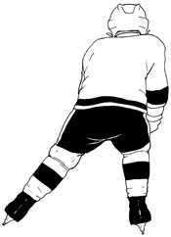
- All weight should be on one foot, with feet close together when stride begins.
- Using the front part of blade, push straight out to side until pushing leg is straight.
- When stride is completed step to the opposite foot and lift the foot you have pushed with.
- Bend knee of free leg and pull it in towards the skating leg keeping the foot close to the ice.
- As free foot comes close to the skating foot, start striding with the opposite leg.
- Continue alternating action with both feet. Ensure weight is over striding leg.

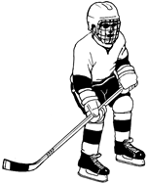
Backward Stance
1 Skating backward is like sitting on a chair.
2 Keep the knees bent and back straight.
3 Feet and knees are shoulder width apart.
4 Lower centre of gravity by keeping the butt down.
5 Keep head up, chest out, and shoulders back.
6 Weight evenly distributed along blade of each skate.

C-Cut for Starting Backward/Backward C-Cut
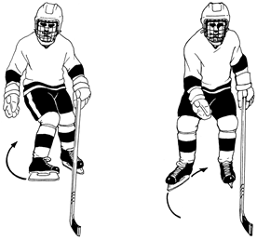
1 Start from basic stance.
2 Turn heel of right skate (driving leg) outward as far as possible. Rotation of leg at the hip also takes place inwards.
3 From bent knee position and pressing on the ball of foot, extend the leg by pushing hard and making a semi-circle cut in the ice with the blade. Ensure weight is on driving leg.
4 Final thrust comes from the toe of the skate blade as the ankle is flexed.
5 Return the right skate to its original place beside the left skate.
6 The left leg (supporting leg) must stay directly under the players’ body.
7 Repeat with left skate.

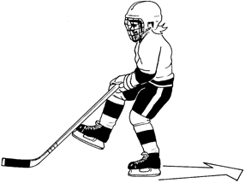
Gliding Backward on One Skate
1 Player is in motion backward.
2 Lift one skate off the ice.
3 Keep supporting leg under player’s centre of gravity.
4 Keep blade of supporting skate flat on the ice, not on the edges.
5 Glide in a straight line.

V-stop for Backward Skating
1 Spread feet shoulder width apart.
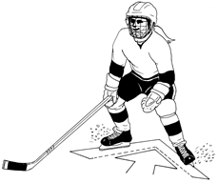
2 The toes of both skates are turned out and the heels are turned in.
3 The body leans forward. This forces the inside edges of skates against the ice.
4 Slight bend in knees during final phase of stop.
5 Legs become extended during final phase of stop. Pressure is thus exerted through the skate blade.
6 When stop is completed the player should end up in the basic stance, prepared to go off in any direction.

Backward Turn
Backward turns in both directions are essential for mobility and positioning, and are skills that should be mastered by all players.

Backward One-foot Stop and T-Push
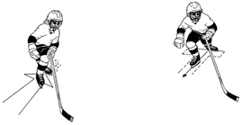
1 Player is in motion backward.
2 Left leg extends and transfers weight to right leg.
3 Left leg now being weightless begins to swing back.
4 Shoulders, hips, and legs turn in a counter-clockwise direction as the left skate is planted in a braking position.
5 Left knee is bent and the weight is transferred from the right leg to the left leg.
6 The majority of resistance comes from the left skate.
7 Right skate and knee move under the body.
8 Skates are now in a position for T-push start.

Pivot (Backward to Forward)
1 Players are in motion backward.
2 To turn to the left, transfer the weight to the right skate.
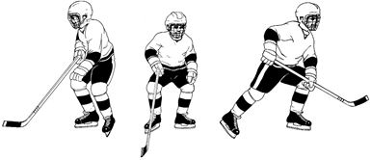
3 Turn is started by rotating the left shoulder backward. The torso and hips will follow.
4 Lift the left skate off the ice and turn it as close to 180° as possible. Glide straight back on right skate.
5 Transfer the weight to the left foot to complete the turn.
6 At moment of weight transfer, the player must dig in the right skate and push hard, fully extending the right leg.
7 You are now ready to start forward striding.
8 It is important to accelerate out of the turn.
9 Must learn to turn to both sides.

Pivot (Forward to Backward)
1 Players gain forward momentum and coast on the left skate.
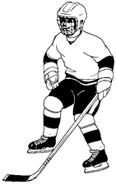
2 The player straightens up and rotates the right skate outward (as close to 180° as possible) in almost a heel to heel position. Turn is started by rotating right shoulder backward. The torso and hips will follow.
3 Transfer the weight from the left skate to the right skate; step down on right skate and unweight your skates by going from bent knees to straight legs. This will help in transferring from left to right skate.
4 Finish pivot by turning the left skate so that it is parallel with the right skate.
5 Push to side with right skate and start to skate backward.
6 Must learn to turn both sides.

Backward Lateral Crossover
Backward lateral crossovers permit a player to move laterally to remain in front of an attacker. They can be executed from a stopped position or while skating backward.
1 Basic stance is the starting position.
2 The hips and trunk turn slightly towards the direction of the crossover; the head remains straight.
3 Facing the play, the body is moved in the desired direction of travel by the extension of the outside leg (inside edge) followed by an extension of the inside leg (outside edge).
4 The outside leg crosses over in front of the inside leg and is brought down on the ice. This action is repeated until the desired position is attained.
5 The body weight is shifted to the leg that remains on the ice.

Backward Crossover Turn
The backward crossover turn is used to shift from backward to forward skating without having to come to a complete stop.
1 Basic stance is the starting position.
2 Head and shoulders open in the direction the player intends to pivot.
3 The outside leg is extended, and exerts force (inside edge) on the ice by a vigorous extension of the hip, knee and ankle.
4 The inside leg (outside edge) is extended and the outside leg (inside edge) is brought back to begin the final stage of backward to forward transition.
5 The inside leg (outside edge) completes its final thrust, the weight is now on the outside leg (inside edge), when the player pivots to assume a forward skating position.

Puckhandling

Puckhandling Stance
1 Stick length.
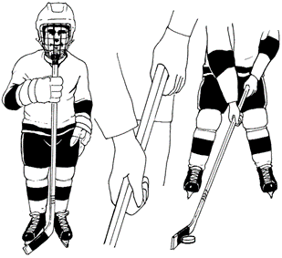
a When on skates, the stick should come up to an area between the collar bone and chin, so that free movement of the top hand in front of the body is possible.
2 Stick lie.
a When assuming the correct skating stance, the blade should be flat on the ice.
b Younger players should have junior size sticks that have narrower shafts and shorter blades.
3 The grip.
a The top hand must be right at the end of the stick.
b The lower hand should be 20 -30 cm down the shaft.
c The “V” formed by the thumb and the forefinger should be pointing straight up the shaft.
d Blade of stick is flat on the ice.
e Keep the head up and use peripheral vision to look at puck. Younger players should be allowed to look and feel for the puck.

Stationary Puckhandling
1 Assume puckhandling stance.
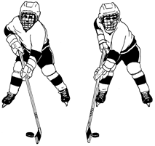
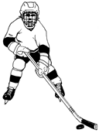
2 Move the puck from side to side by rolling the wrists. This cups the stick on both the forehand and backhand, thus, allowing better control.
3 To roll the wrists, turn the toe of the blade inwards and the heel outwards, then reverse direction.
4 Puck is handled in the middle of the blade.
5 Keep arms and upper body relaxed.
6 Puck control must be smooth, rhythmical, and quiet.

Open-ice Carry
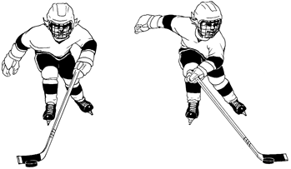
1 Players have control of stick with top hand only. The puck is pushed ahead with the bottom edge of the stick blade.
2 Arm action is slight forward thrust by straightening the arm at the elbow.
3 The puck should be pushed alternately with the blade pointed to the left then to the right.
4 Push the puck only slightly ahead.

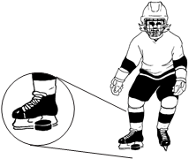
Use of Feet to Control the Puck
1 Turn toe out so that puck can be controlled by the skate blade.
2 Players should take a quick look down but not for too long. Try to keep head up.
3 Keep puck within one metre of skates.

Stopping with Puck
1 When stopping, the puck is kept under control by cupping the stick blade over the puck.
2 Keep two hands on the stick.
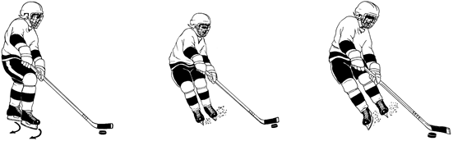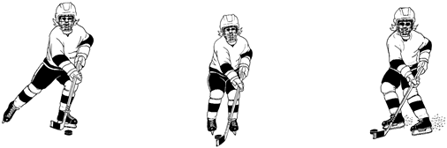

Touching Knee to Ice while Controlling the Puck
1 Player should slide bottom hand down the shaft of stick, this keeps blade flat on the ice.
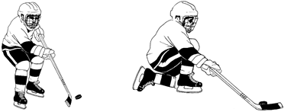

Passing
Passing is a skill that requires a great deal of practice. Introducing your players to all aspects of this skill is essential.

Key Points
- The hands should be in a comfortable position, similar to that used when dribbling the puck.
- The arms should be held out in front of the body.
- The eyes are fixed on the target. (Note: the head does not necessarily turn to face the target, as this would telegraph the pass.)
- The stick blade is perpendicular to the target upon releasing the puck.
- The stick blade follows through towards the target.
- The passer should use the appropriate type of pass in a given situation.
- A pass should not force the receiver to slow down. A passer should “lead” a receiver in motion, thus permitting reception in full stride.
- When it is not possible to pass to the stick of the receiver, pass to the skates, behind the receiver, or to an open space.
- The passer ordinarily does not stop skating after making the pass, but moves to a position of support.
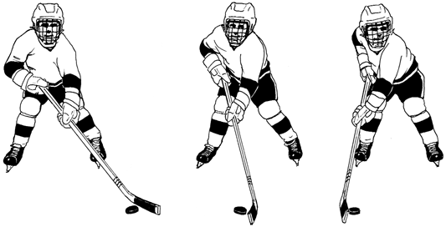

Forehand Passing

Forehand Sweep Pass
NOTE: It is very important that each player has a stick which is not too long.
1 Player is in the normal puckhandling stance.
2 Bring the puck beyond the plane of the body. Puck is in the middle portion of the stick blade.
3 Stick blade should be at right angles to the target.
4 Body weight is on the back leg.
5 Head is up looking at the target.
6 Puck is propelled toward target with a sweeping action of the arms. Pull with the top hand and push with the bottom hand.
7 As the puck is propelled, the weight is transferred from the rear leg to the front leg.
8 Follow through low and towards the target.
9 Be prepared to receive.

Receiving a Pass
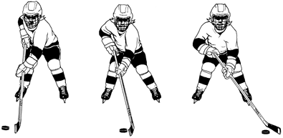
1 Head up looking at the puck.
2 Present a target, stick blade on the ice.
3 Keep blade at 90° toward direction of puck.
4 As the puck contacts the blade, some give is allowed providing a cushioning effect.
5 Be prepared to pass.

Backhand Passing
It is essential that the backhand pass be perfected. As it is a very difficult skill, it should be given special attention.

Key Points
- The grip on the stick is similar to that used when stickhandling and tightens during the passing action.
- The weight of the body should be transferred from the leg furthest from the receiver to the closest leg.
- The upper hand must move in front of the body to maintain the blade perpendicular to the target.
- The length of the sweep will depend on the time available and the distance of the receiver.
- A player’s long-term goal should be to execute a backhand pass without cutting down on skating speed, changing direction or excessively rotating the shoulders.

Backhand Sweep Pass
1 Hands are well away from the body.
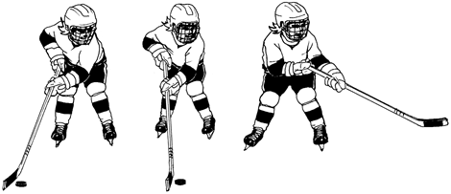
2 Bring the puck beyond the plane of the body.
3 Shift the weight to the back leg.
4 Head up, looking at target.
5 Cup the blade of the stick over the puck.
6 Sweeping action of stick across the body to slide the puck.
7 Shift weight to the front foot.
8 Snap and roll wrists.
9 Follow through low.
10 Be prepared to receive.

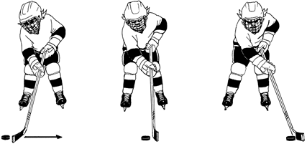
Receiving Pass Backhand
1 Head up watching puck.
2 Stick is on the ice for a target.
3 Cup your stick and cushion the impact by relaxing the wrists.
4 Be prepared to pass.

Board Pass to Partner
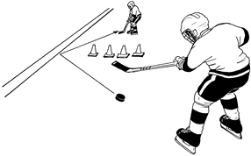
1 Make boards work for you in passing the puck.
2 Used frequently by defenseman in their own zone.
3 Useful when a defender is between you and your receiver.
4 A puck passed off the board’s rebounds away at the same angle. In other words, the angle onto the boards equals the angle off of the boards.

Shooting
The ability to shoot the puck in various situations that arise during a game of hockey is an invaluable skill.
Hockey players should have a complete arsenal of shots from which to choose. An incomplete player is limited to only one or two types of shots.
1 Accuracy is the most important. (Hard, quick shots that miss the net are not much of a threat.)
2 Get the stick blade travelling as fast as possible.
3 Speed of execution (i.e. quick release) is as important as the speed of the puck. The element of surprise is a very important factor in shooting.
4 When advantageous, make use of possible screens when shooting at the goal.
5 Always keep the stick close to the ice around the net, and react to the movement of the puck after each shot (e.g. a rebound.)
6 Master the various shots in order to have the right shot for any game situation.
For a better understanding of shooting skills, each shot can be broken down into three phases: preparatory, execution and follow-through. This breakdown also permits a better and more complete analysis of the skill, and thus facilitates corrections.

Phases of Shooting

Preparatory Phase
1 Preparation to release the shot (e.g. backswing in a slap shot).
2 Movement of 4 joints into position.

Execution Phase
1 Forces generated in the direction of the shot.
2 Impact of the stick with the puck.
3 Body movements (e.g. trunk rotation, weight transfer and stick flexion).

Follow-through Phase
1 Begins once the puck leaves the blade of the stick.
2 A good follow-through ensures that body segments do not decelerate too soon.

Forehand Shooting

Forehand Sweep Shot
1 Basically the same grip as passing.
2 Bring puck beyond plane of the body.
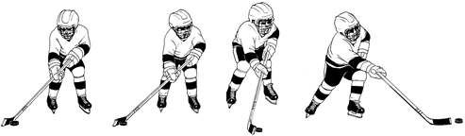
3 Weight is on the back leg.
4 In the process of sweeping the puck through, the weight is transferred to the front foot.
5 Head up, looking for opening.
6 Snap and roll the wrists. Push the top hand and pull the bottom hand.
7 Release the puck, and follow through low.

Forehand Wrist Shot
The wrist shot is a surprise shot that depends on the quickness of release. It is a useful shot around the opponent’s net, where space and time are often limited.
1 The spread of the hands on the stick is somewhat wider than that used when stickhandling.
2 The puck is brought to the side of the body, and should be well behind the left skate.
3 Maximum force is transferred to the stick by bending the trunk forward and shifting body weight from the back to the front leg.
4 The grip should tighten and the wrists should snap before or as the puck reaches the forward leg.
5 The puck is propelled with a snap of the wrists. In one motion, the top hand snaps forward then back towards the body while the wrist is rapidly extended. The bottom wrist flexes and whips the stick through towards the target.

Forehand Flip Shot
A technique used to hit the upper corners of the net from close in, or to lift the puck over the sprawling goalkeeper.
1 Puck is on the toe of the stick blade which is near the front foot.
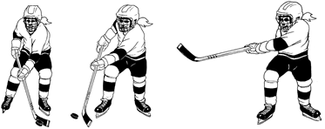
2 Lift is given by tilting the blade so that only its bottom edge contacts the puck.
3 Deliver from in front of the body with a scooping action of the stick by the wrists.
4 Need a quick snap of the wrists and a high follow through.
Backhand is similar, except puck is closer to the heel of the blade to get better action.

Backhand Shooting

Backhand Sweep Shot
The sweep shot is perhaps the most commonly used backhand shot. It is both fast and accurate.
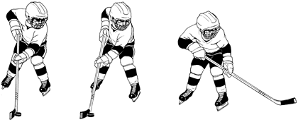
1 Basically same grip as passing.
2 Bring puck beyond plane of the body.
3 Weight is on the back leg.
4 In the process of sweeping the puck through the weight is transferred to the front foot.
5 Head up looking for opening.
6 Snap and roll the wrists. Push the top hand and pull the bottom hand.
7 Release the puck and follow through low.

Backhand Wrist Shot
The backhand wrist shot is usually used by a player who has faked a move to the forehand side to bring the puck to the backhand for a quick shot on the goaltender. Since the player is in a forward skating position, the wrist shot becomes the best tool in this particular situation.
1 The hands are spaced slightly farther apart than during the dribble.
2 The puck is placed on the heel of blade to the side and slightly in front of the player.
3 The puck is then whipped in the direction of the goal by a vigorous rotation of the shoulders and a dynamic action of the arms and wrists.
4 There is a limited transfer of weight.

Deke
The deke is a second means accessible to a player who wishes to become free of an opponent and maintain possession of the puck. It may also precede a pass or shot in order to mislead an opponent.

Key Points
- A fake must be based on deception by having all the appearance of reality.
- Dekes should be initiated at a sufficient distance from an opponent to avoid being stick checked.
- Changes of speed and direction are important factors to the success of any deke.
- Acceleration after completing the deke is often important (be certain that drills allow for practice of this).
- If possible, dekes should be based on a knowledge of the opponent’s weaknesses.
- A deke must give the opponent enough time to go for the fake before the player undertakes the intended action.
- While deking an opponent, the player would make an effort to remain fully aware of the whereabouts of teammates and opponents.
It is important to remember that dekes are a creation of the imagination that can be perfected through practice. Here are some basic dekes which can be modified or combined in many ways to suit the situation, the skills and needs of each player.

Body Fake
- Change of Direction: the player feints with the head and / or shoulders in one direction, then goes in the other direction.
- Between the Legs: After a deke with the head, shoulders or stick, the player slips the puck between the opponent’s legs and recovers it behind the opponent.

Skating Fake
- Stop and Start: the player skates at full speed as if to outskate the opponent, then stops abruptly and starts in another direction.
- Change of Speed: the player slows down, forcing the opponent to do the same, then accelerates rapidly, catching the opponent flat-footed.
- Directional Skating: the player does crossovers in one direction, and when the opponent moves to cover, cuts back in the other direction.
- Using the Boards: the player acts as if to skate between the player and the boards, but cuts around the opponent, banks the puck off the boards and then retrieves it.
- Body Deke: Drop your head, shoulder, or hips, one way, then the other.

Stick Fake
- Fake a Shot: the player fakes a shot, waits until the opponent reacts, then skates around the opponent.
- Fake a Pass: The player fakes a pass with the head or the stick, then shoots on goal, or dekes the opponent.

